**MACHINE LEARNING**

**WITH MATLAB**

**Data science assignment**

**Name:Anish.D**

**SRN:PES1201801334**

**ROLL NO:29**

**SECTION:A**

**DEPARTMENT:ECE**

**CAMPUS:RR CAMPUS**

**SEM:5**

Import Data

Instructions are in the task pane to the left. Complete and submit each task one at a time.

This code creates a string array of player positions.

positions = ["G","G-F","F-G","F","F-C","C-F","C"]

positions = 1×7 string

"G" "G-F" "F-G" "F" "F-C" "C-F" "C"

**Task 1**

playerInfo=readtable("bballPlayers.txt")

playerInfo = 1250×5 table

**Task 2**

playerInfo.pos=categorical(playerInfo.pos)

playerInfo = 1250×5 table

**Task 3**

playerInfo.pos=categorical(playerInfo.pos,positions)

playerInfo = 1250×5 table

**Task 4**

playerInfo=rmmissing(playerInfo)

playerInfo = 1167×5 table

**Task 5**

allStats=readtable("bballStats.txt");

**Task 6**

allStats(:,19:end)=[]

allStats = 4587×18 table

**Further Practice**

idx=playerInfo.name == "LeBron James";

ID=playerInfo.playerID(idx)

ID = *1×1 cell array*

{'jamesle01'}

LJstats=allStats(allStats.playerID == string(ID),:)

LJstats = 8×18 table

# Group and Merge Data

Instructions are in the task pane to the left. Complete and submit each task one at a time.

This code imports and formats the tables playerInfo and allStats.

playerInfo = readtable("bballPlayers.txt");

positions = ["G","G-F","F-G","F","F-C","C-F","C"];

playerInfo.pos = categorical(playerInfo.pos,positions);

playerInfo = rmmissing(playerInfo)

playerInfo = 1167×5 table

allStats = readtable("bballStats.txt");

allStats(:,19:end) = []

allStats = 4587×18 table

## **Task 1**

playerStats=groupsummary(allStats,"playerID","sum")

playerStats = 609×19 table

## **Task 2**

playerStats.GroupCount=[]

playerStats = 609×18 table

playerStats.Properties.VariableNames=allStats.Properties.VariableNames

playerStats = 609×18 table

## **Task 3**

data=innerjoin(playerInfo,playerStats)

data = 609×22 table

## **Further Practice**

joinedData = 5145×23 table

# Explore Data

Instructions are in the task pane to the left. Complete and submit each task one at a time.

This code loads the table data which contains the basketball player data.

load bballData.mat

data

data = 609×22 table

## **Task 1**

boxplot(data.height,data.pos)

ylabel("Height (inches)")

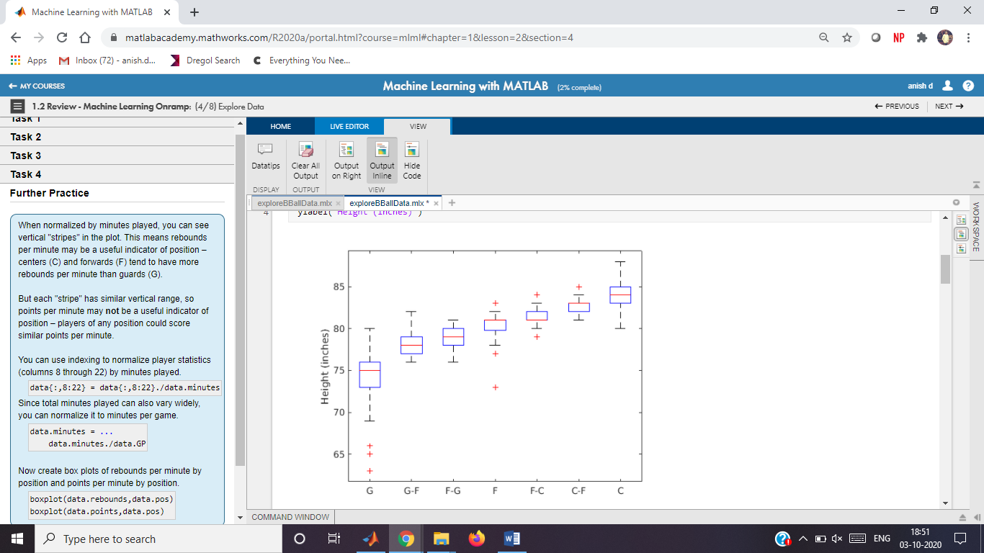

## **Task 2**

gscatter(data.rebounds,data.points,data.pos)

xlabel("Rebounds")

ylabel("Points Scored")

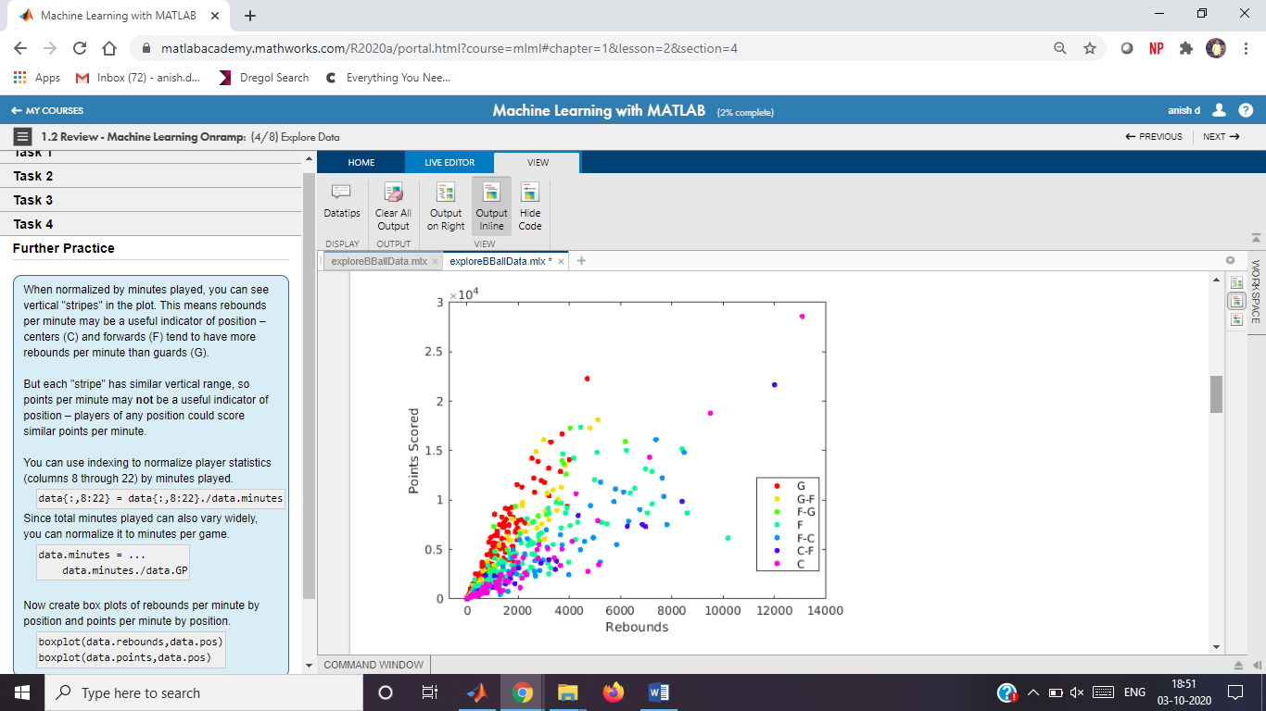

## **Task 3**

gscatter(data.rebounds./data.GP,data.points./data.GP,data.pos)

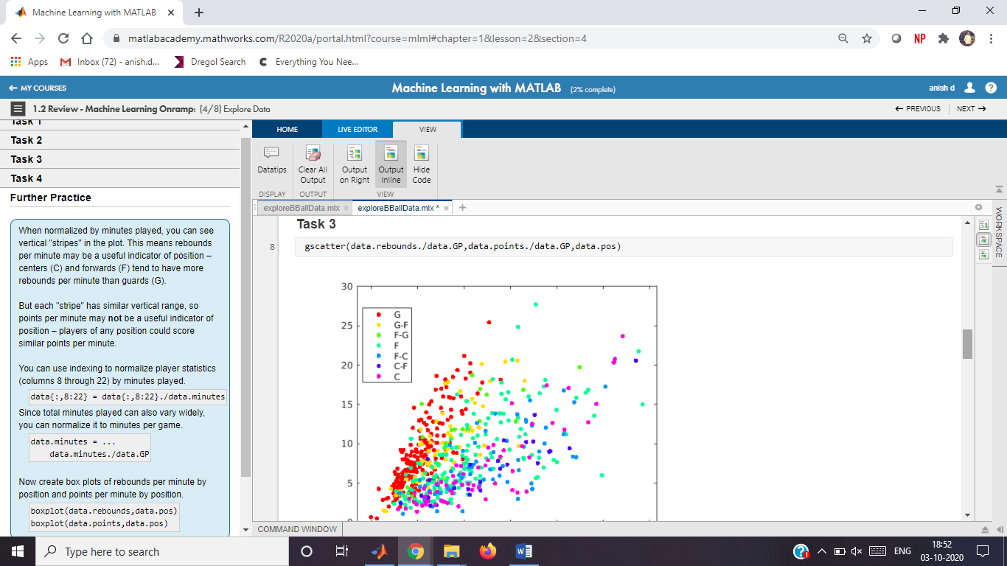

## **Task 4**

gscatter(data.rebounds./data.minutes,data.points./data.minutes,data.pos)

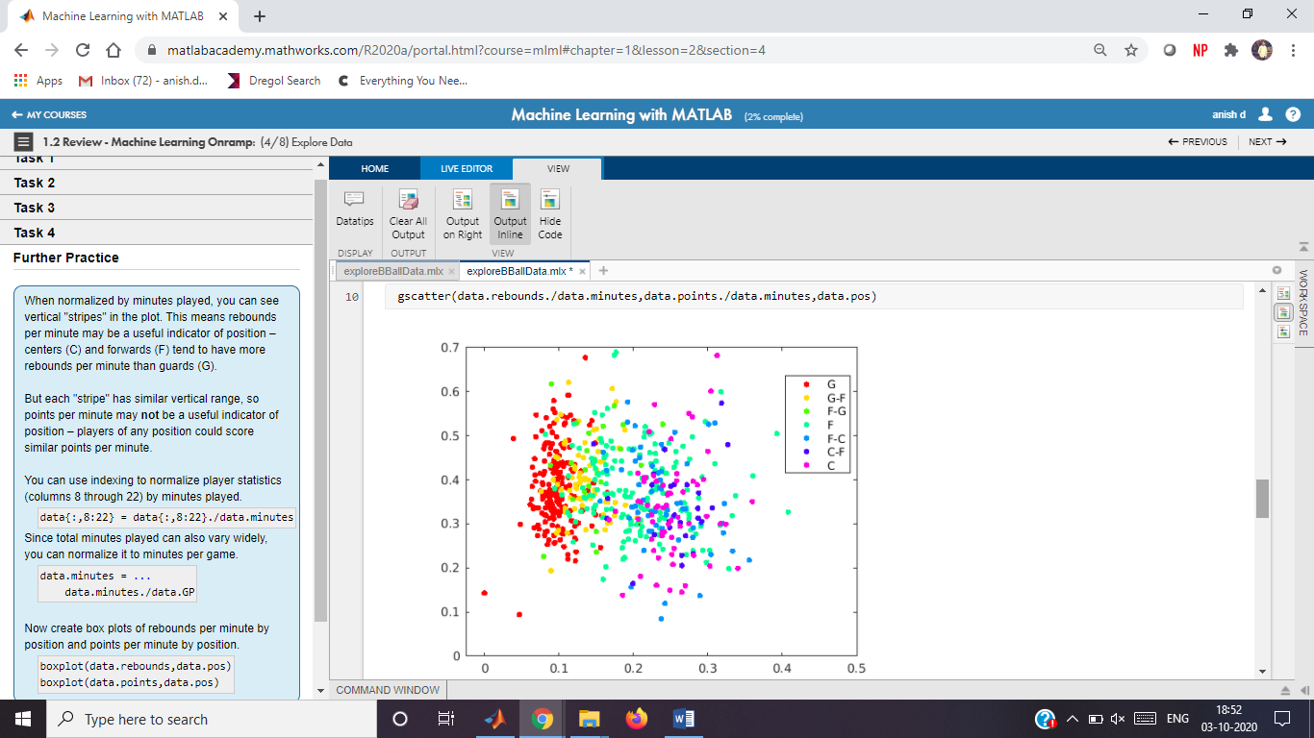

## **Further Practice**

data{:,8:22}=data{:,8:22}./data.minutes

data = 609×22 table

data.minutes=data.minutes./data.GP

data = 609×22 table

boxplot(data.rebounds,data.pos)

boxplot(data.points,data.pos)

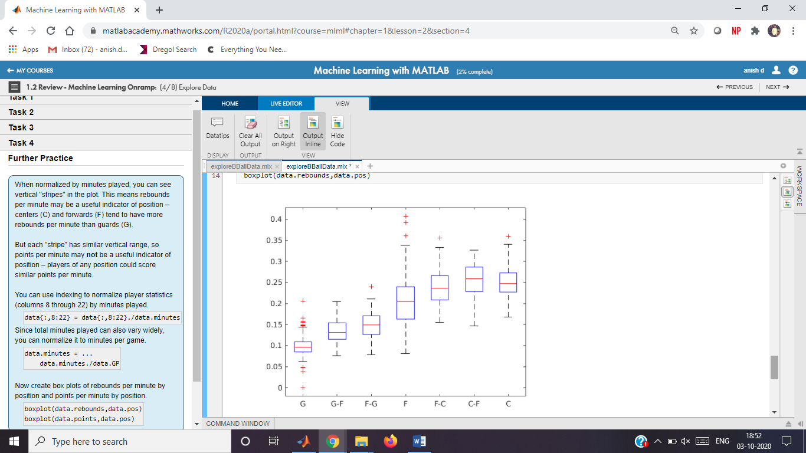

# Train a Model and Make Predictions

Instructions are in the task pane to the left. Complete and submit each task one at a time.

This code loads and displays the normalized (per minute) data set.

load bballTrainingData

data

data = 609×22 table

whos

Name Size Bytes Class Attributes  
  
 data 609x22 253417 table   
 dataTest 182x20 33820 table   
 dataTrain 427x20 71305 table   
 knnmodel 1x1 79756 ClassificationKNN   
 mdlLoss 1x1 8 double   
 predPos 182x1 942 categorical

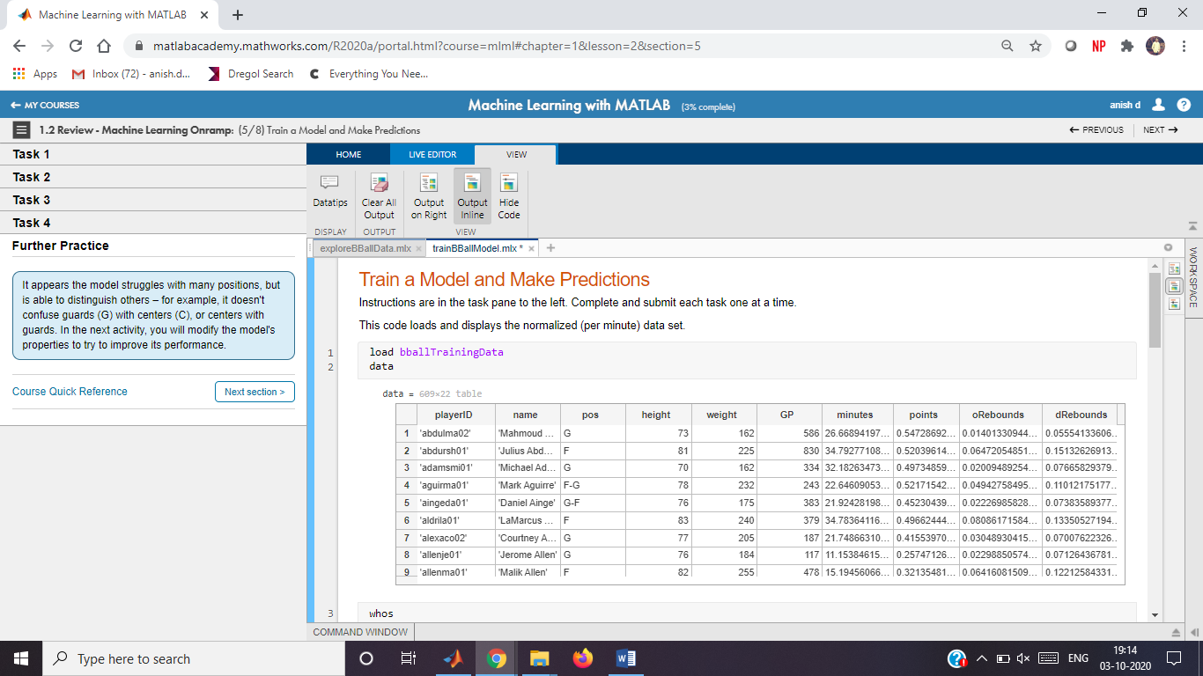

## **Task 1**

knnmodel=fitcknn(dataTrain,"pos")

knnmodel =

ClassificationKNN  
 PredictorNames: {'height' 'weight' 'GP' 'minutes' 'points' 'oRebounds' 'dRebounds' 'rebounds' 'assists' 'steals' 'blocks' 'turnovers' 'PF' 'fgAttempted' 'fgMade' 'ftAttempted' 'ftMade' 'threeAttempted' 'threeMade'}  
 ResponseName: 'pos'  
 CategoricalPredictors: []  
 ClassNames: [G G-F F-G F F-C C-F C]  
 ScoreTransform: 'none'  
 NumObservations: 427  
 Distance: 'euclidean'  
 NumNeighbors: 1  
  
  
 Properties, Methods

## **Task 2**

predPos=predict(knnmodel,dataTest)

predPos = 182×1 categorical

G-F   
C   
G   
F-C   
F   
G   
F   
G   
G   
G

## **Task 3**

mdlLoss=loss(knnmodel,dataTest)

mdlLoss =

0.632248263562002

## **Task 4**

confusionchart(dataTest.pos,predPos)

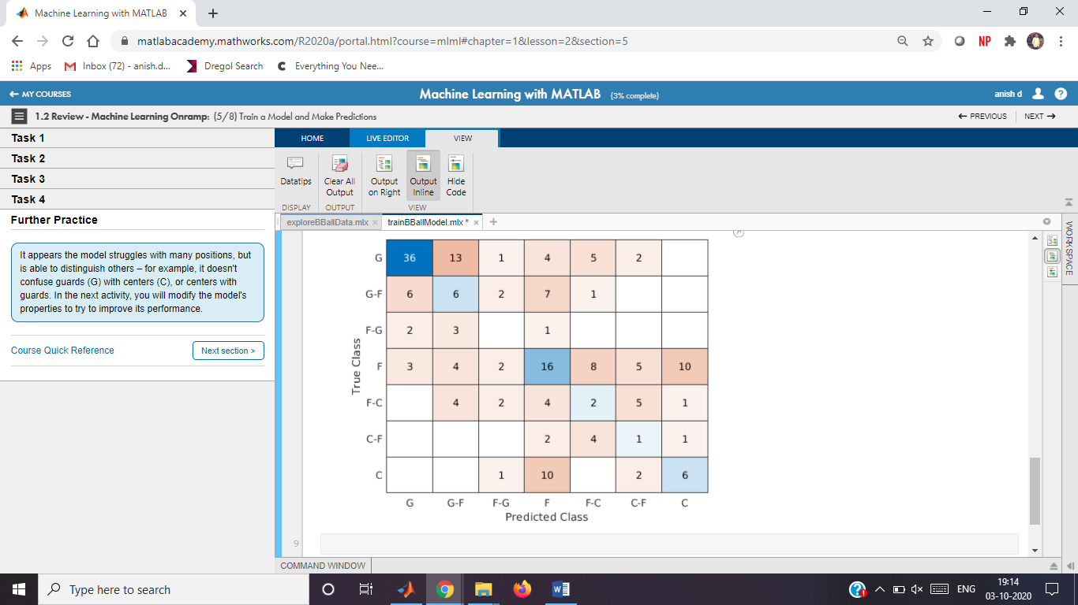

## **Further Practice**

# Predicting Player Position

Instructions are in the task pane to the left. Complete and submit each task one at a time.

## **Load data**

Load the basketball player statistics (per minute) data set.

load bballTrainingData.mat

whos

Name Size Bytes Class Attributes  
  
 data 609x22 253417 table   
 dataTest 182x20 33820 table   
 dataTrain 427x20 71305 table

## **Train kNN model**

Fit a kNN classification model to the training data.

knnmodel = fitcknn(dataTrain,"pos","NumNeighbors",5,"Standardize",true);

## **Evaluate model**

Calculate misclassification rate.

mdlLoss = loss(knnmodel,ataTest)

mdlLoss =

0.408488539314294

Display a confusion chart.

predPos = predict(knnmodel,dataTest);

confusionchart(dataTest.pos,predPos);

title("Player Position")

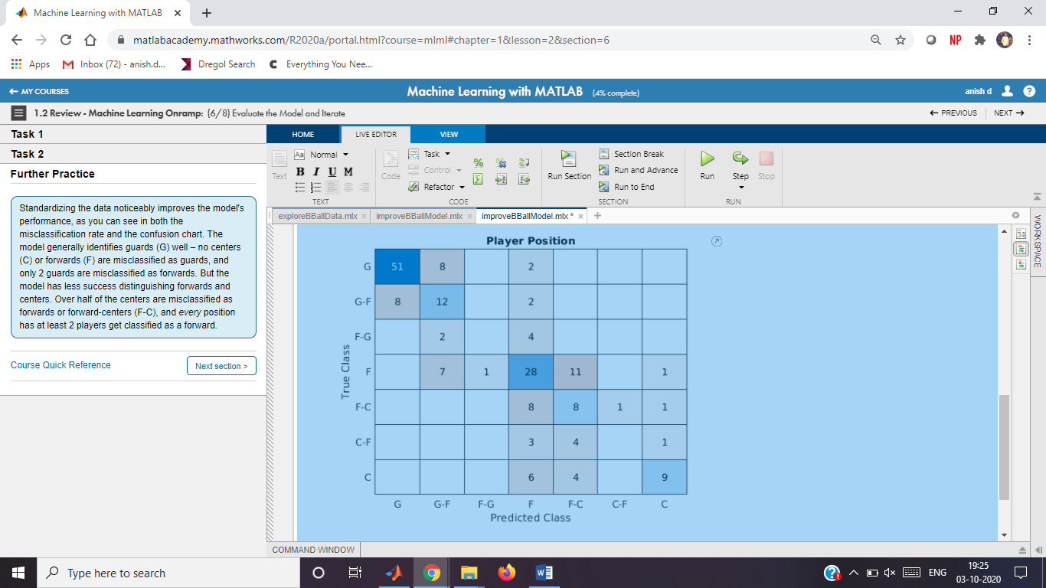

## **Further Practice**

# Classical Multidimensional Scaling

Instructions are in the task pane to the left. Complete and submit each task one at a time.

This code loads and displays the data.

load data;

whos X;

Name Size Bytes Class Attributes  
  
 X 124x4 3968 double

## **Task 1**

D=pdist(X)

D = 1×7626

2.0250 3.2150 2.8857 0.8190 4.0122 2.7162 3.4925 2.9274 1.9251 2.0929 2.0482 2.4460 1.5394 1.4666 4.2891 1.7114 2.1354 2.7378 0.9318 1.2971 2.2531 1.4692 1.4127 2.1062 0.8100 2.5849 1.0226 2.8476 3.1070 2.4005 5.0555 2.0674 1.2046 2.1360 1.4733 3.5514 1.7065 1.6416 2.7010 1.0674 2.3241 1.1654 2.7345 1.6539 2.1314 1.0888 2.4780 1.0482 3.1955 2.6307

## **Task 2**

[Y e]=cmdscale(D)

Y = 124×4

5.1696 -1.2944 1.1102 -0.0717  
 7.0363 -1.5951 0.4156 0.1360  
 5.0959 -2.2218 -1.9668 -0.0208  
 6.5495 -1.1599 -1.4205 -0.0591  
 5.1581 -1.4514 0.3076 -0.0293  
 5.4756 -0.0992 4.9281 -0.0875  
 4.0896 0.6602 2.6558 -0.1166  
 6.0890 -2.1255 -2.1387 0.2543  
 5.4512 0.2453 3.5730 0.1621  
 6.8605 -0.7875 0.3488 0.0298

e = 124×1

103 ×

3.3604  
 1.2747  
 0.3685  
 0.0010  
 0.0000  
 0.0000  
 0.0000  
 0.0000  
 0.0000  
 0.0000

## **Task 3**

pareto(e)

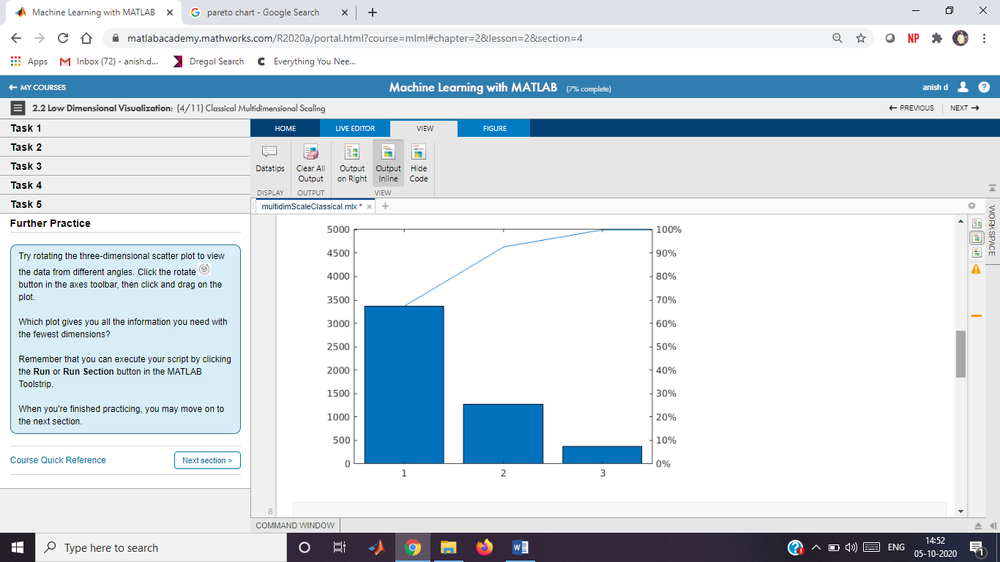

## **Task 4**

scatter(Y(:,1),Y(:,2))

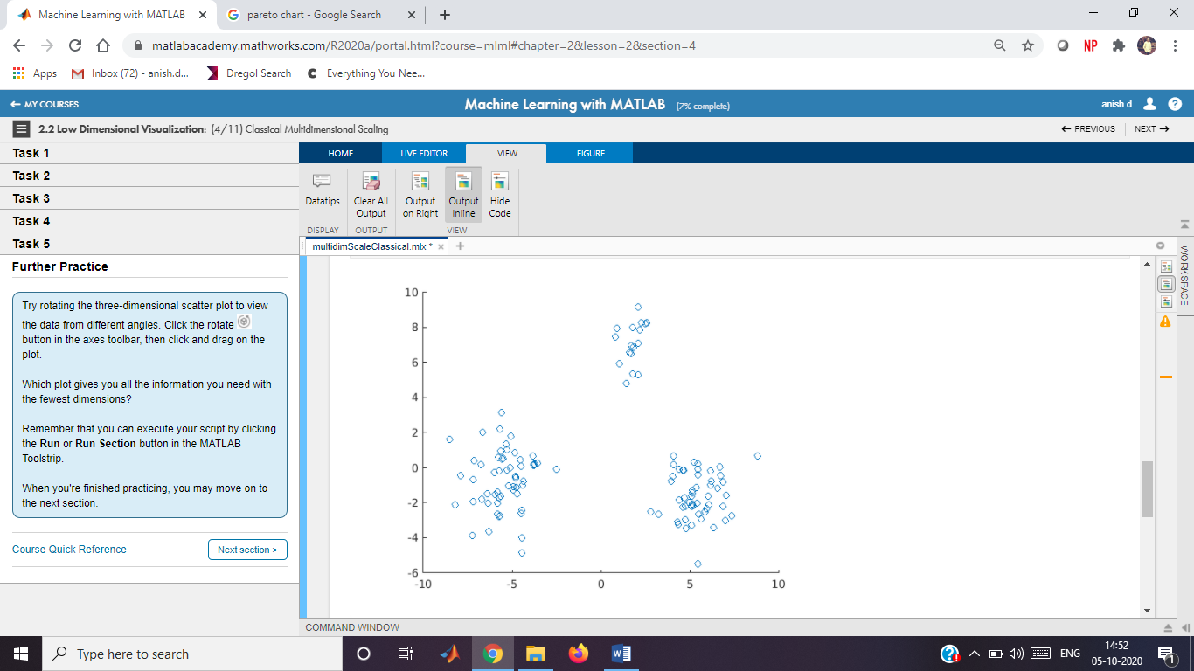

## **Task 5**

scatter3(Y(:,1),Y(:,2),Y(:,3))

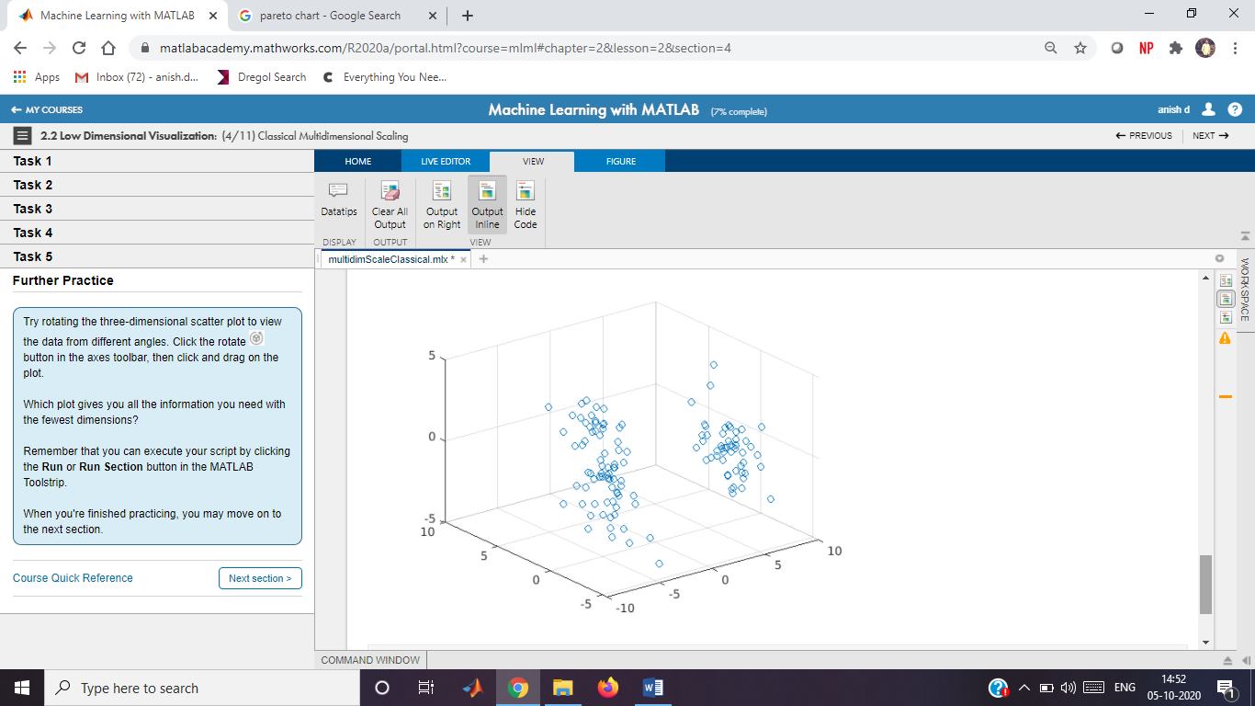

## **Further Practice**

Nonclassical Multidimensional Scaling

Instructions are in the task pane to the left. Complete and submit each task one at a time.

This code loads and displays the data.

load data;

whos X;

Name Size Bytes Class Attributes  
  
 X 124x4 3968 double

**Task 1**

D=pdist(X)

D = 1×7626

2.0250 3.2150 2.8857 0.8190 4.0122 2.7162 3.4925 2.9274 1.9251 2.0929 2.0482 2.4460 1.5394 1.4666 4.2891 1.7114 2.1354 2.7378 0.9318 1.2971 2.2531 1.4692 1.4127 2.1062 0.8100 2.5849 1.0226 2.8476 3.1070 2.4005 5.0555 2.0674 1.2046 2.1360 1.4733 3.5514 1.7065 1.6416 2.7010 1.0674 2.3241 1.1654 2.7345 1.6539 2.1314 1.0888 2.4780 1.0482 3.1955 2.6307

Y=mdscale(D,2)

Y = 124×2

-5.2761 -1.0903  
 -6.9296 -1.6278  
 -5.1333 -2.8046  
 -6.5811 -1.5753  
 -5.2105 -1.3571  
 -6.9345 1.1404  
 -4.4601 0.9212  
 -6.1572 -2.8471  
 -6.1576 0.8986  
 -6.7452 -1.0029

**Task 2**

scatter(Y(:,1),Y(:,2))

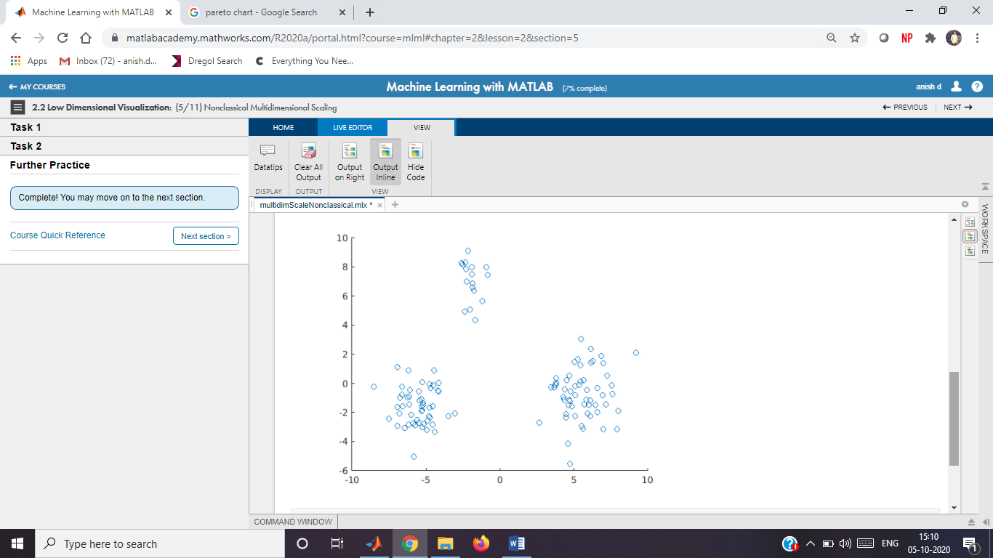

**Further Practice**

Principal Component Analysis

Instructions are in the task pane to the left. Complete and submit each task one at a time.

This code loads and displays the data.

load data;

whos X;

Name Size Bytes Class Attributes  
  
 X 124x4 3968 double

**Task 1**

[pcs,scrs,~,~,pexp]=pca(X)

pcs = 4×4

-0.0023 0.7120 0.7022 -0.0015  
 0.8936 -0.3138 0.3211 0.0009  
 0.4489 0.6282 -0.6355 -0.0013  
 -0.0002 0.0021 -0.0000 1.0000

scrs = 124×4

5.1696 -1.2944 1.1102 -0.0717  
 7.0363 -1.5951 0.4156 0.1360  
 5.0959 -2.2218 -1.9668 -0.0208  
 6.5495 -1.1599 -1.4205 -0.0591  
 5.1581 -1.4514 0.3076 -0.0293  
 5.4756 -0.0992 4.9281 -0.0875  
 4.0896 0.6602 2.6558 -0.1166  
 6.0890 -2.1255 -2.1387 0.2543  
 5.4512 0.2453 3.5730 0.1621  
 6.8605 -0.7875 0.3488 0.0298

pexp = 4×1

67.1458  
 25.4710  
 7.3635  
 0.0197

**Task 2**

pareto(pexp)

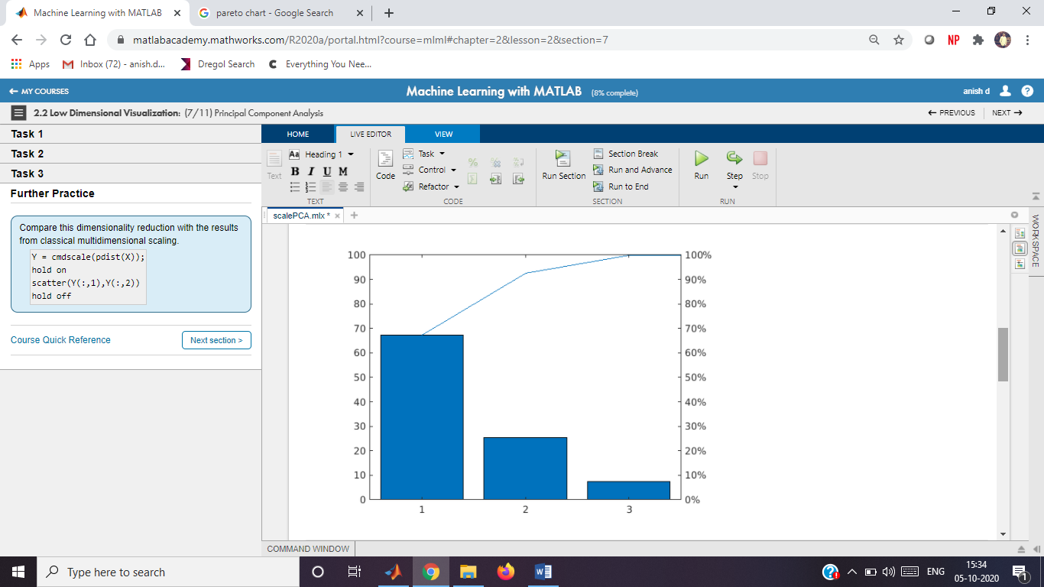

**Task 3**

scatter(scrs(:,1),scrs(:,2))

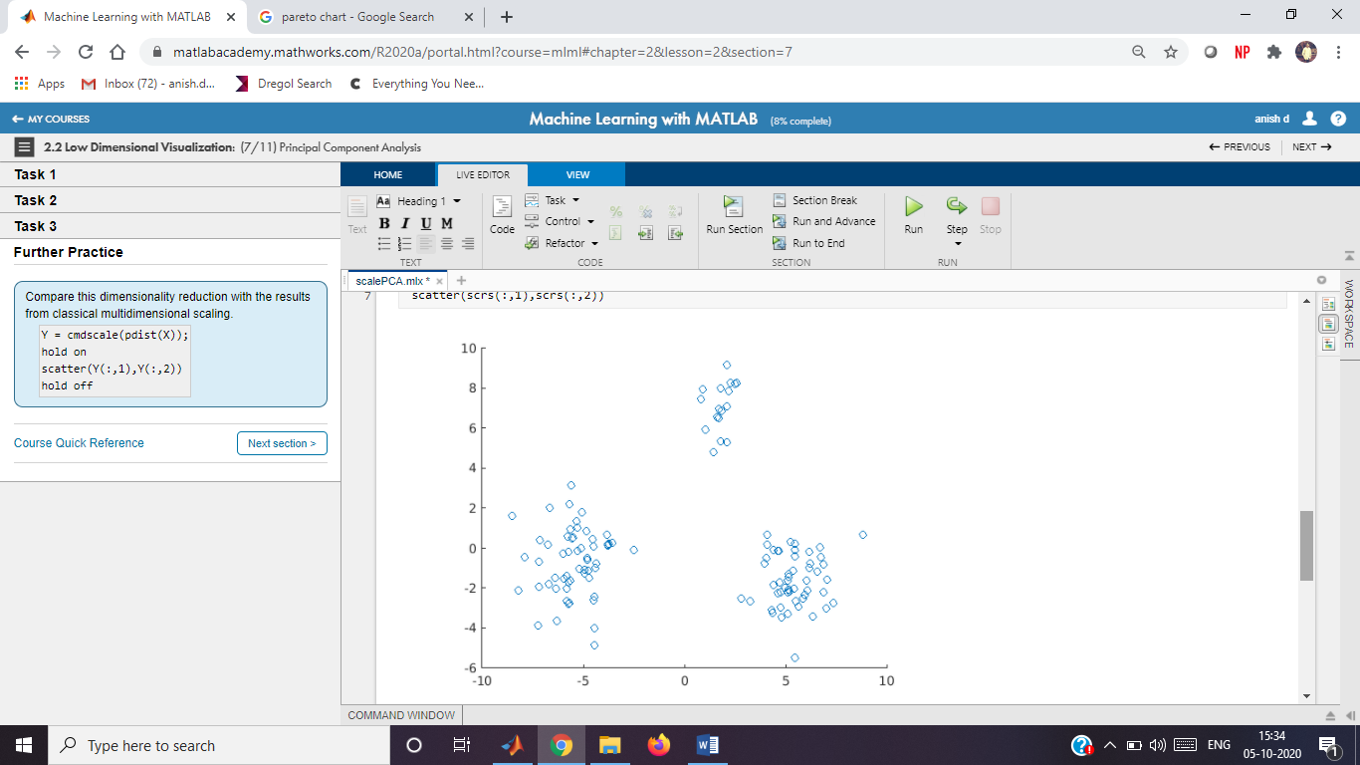

**Further Practice**

Y = cmdscale(pdist(X));

hold on

scatter(Y(:,1),Y(:,2))

hold off

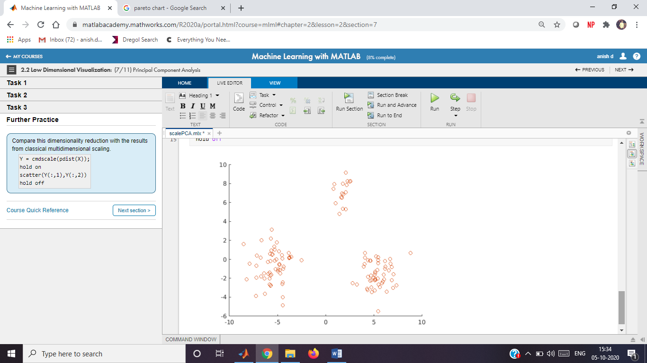

Basketball Players

Instructions are in the task pane to the left. Complete and submit each task one at a time.

This code loads and formats the data.

data = readtable("bball.txt");

data.pos = categorical(data.pos);

This code extracts and normalizes the columns of interest.

stats = data{:,[5 6 11:end]};

statsNorm = normalize(stats);

**Task 1**

pd = pdist(statsNorm);

[Y,e] = cmdscale(pd);

pareto(e)

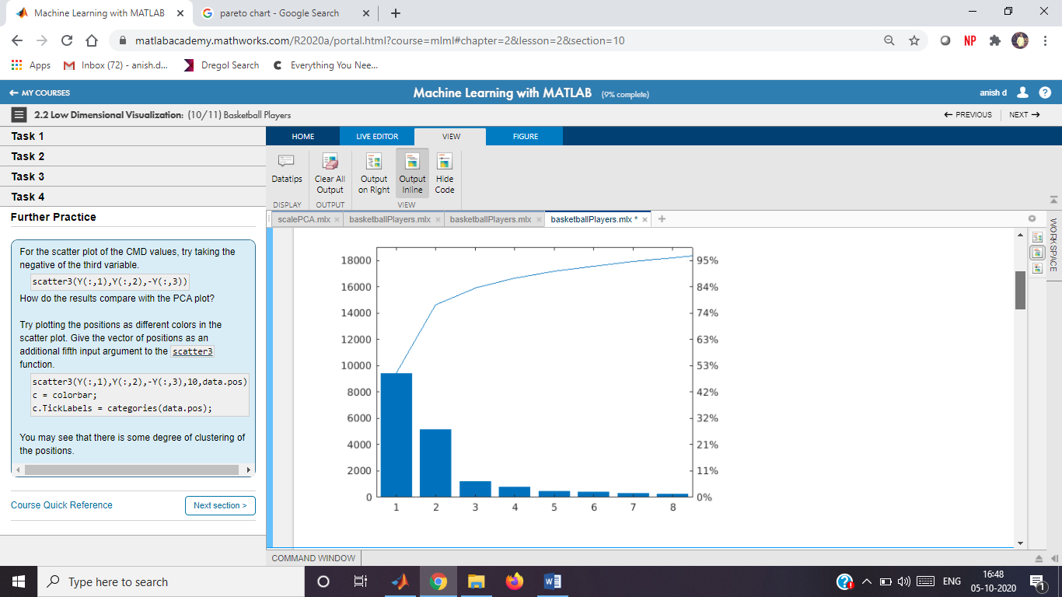

**Task 2**

scatter3(Y(:,1),Y(:,2),Y(:,3))

view(110,40)

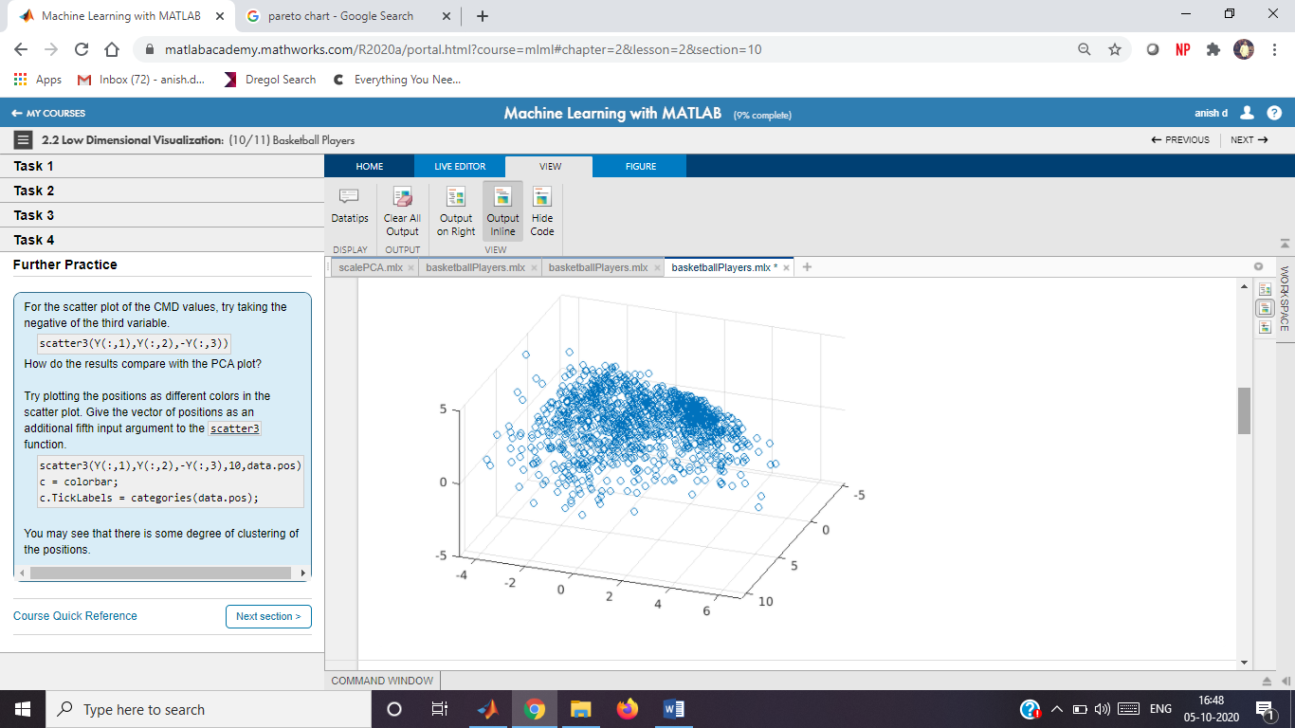

**Task 3**

[~,scrs,~,~,pexp] = pca(statsNorm);

pareto(pexp)

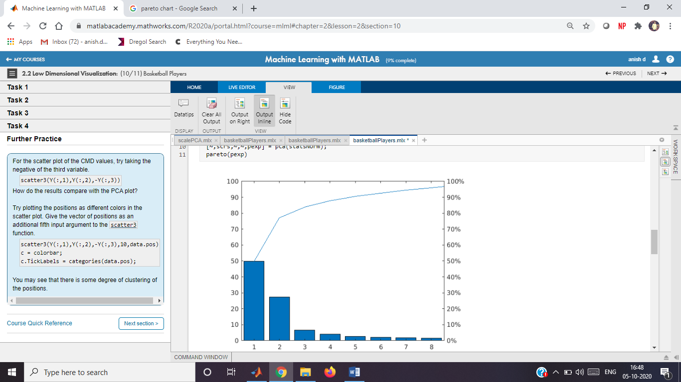

**Task 4**

scatter3(scrs(:,1),scrs(:,2),scrs(:,3))

view(110,4)

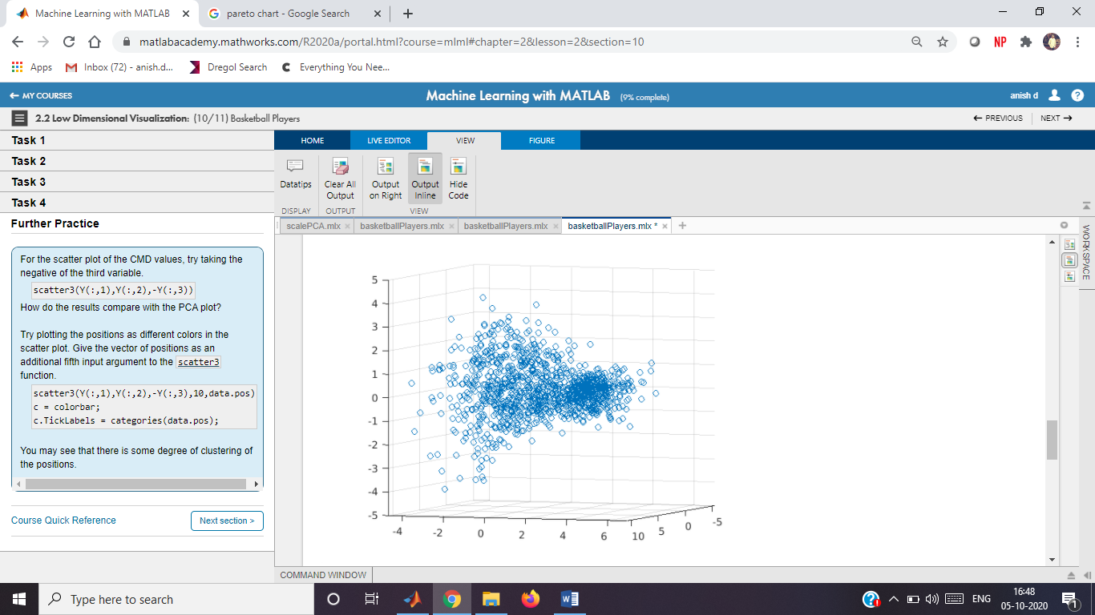

**Further Practice**

scatter3(Y(:,1),Y(:,2),-Y(:,3))

scatter3(Y(:,1),Y(:,2),-Y(:,3),10,data.pos)

c = colorbar;

c.TickLabels = categories(data.pos);

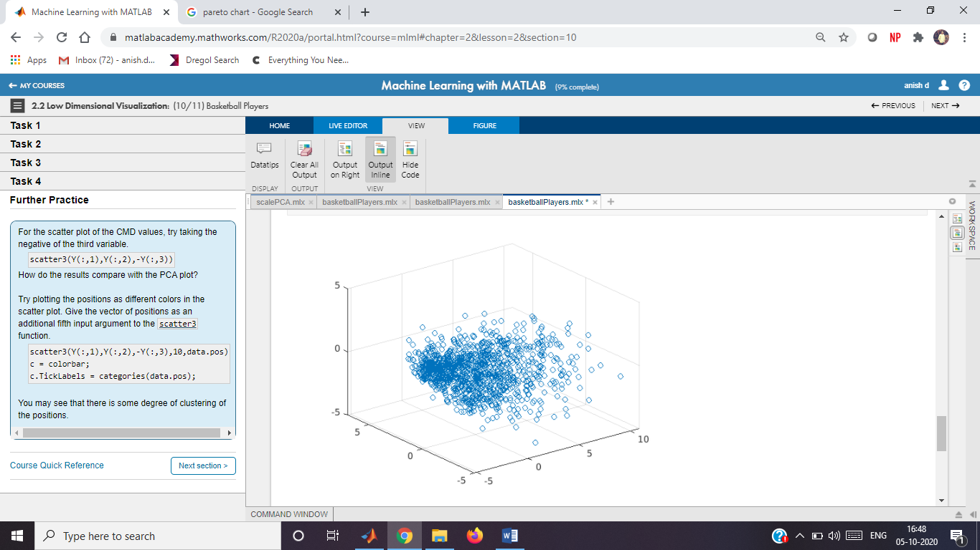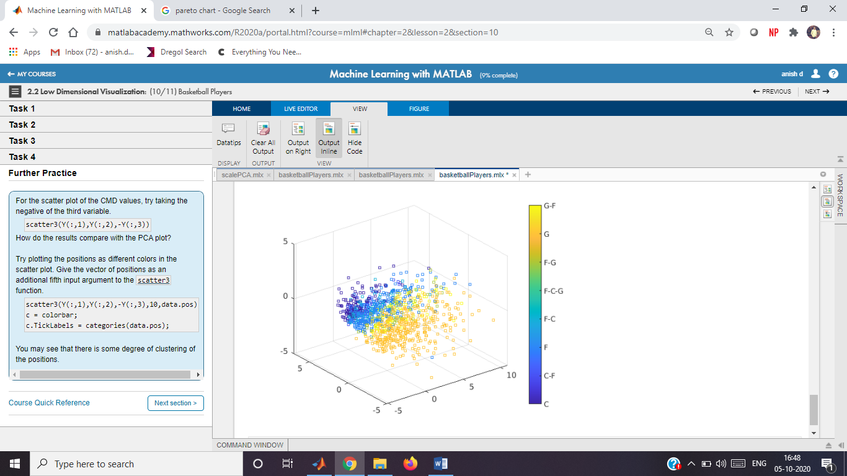

# k-Means Clustering

Instructions are in the task pane to the left. Complete and submit each task one at a time.

This code loads and displays the data.

load data;

whos X;

## **Task 1**

grp=kmeans(X,3)

## **Task 2**

scatter(X(:,1),X(:,2),10,grp)

## **Further Practice**

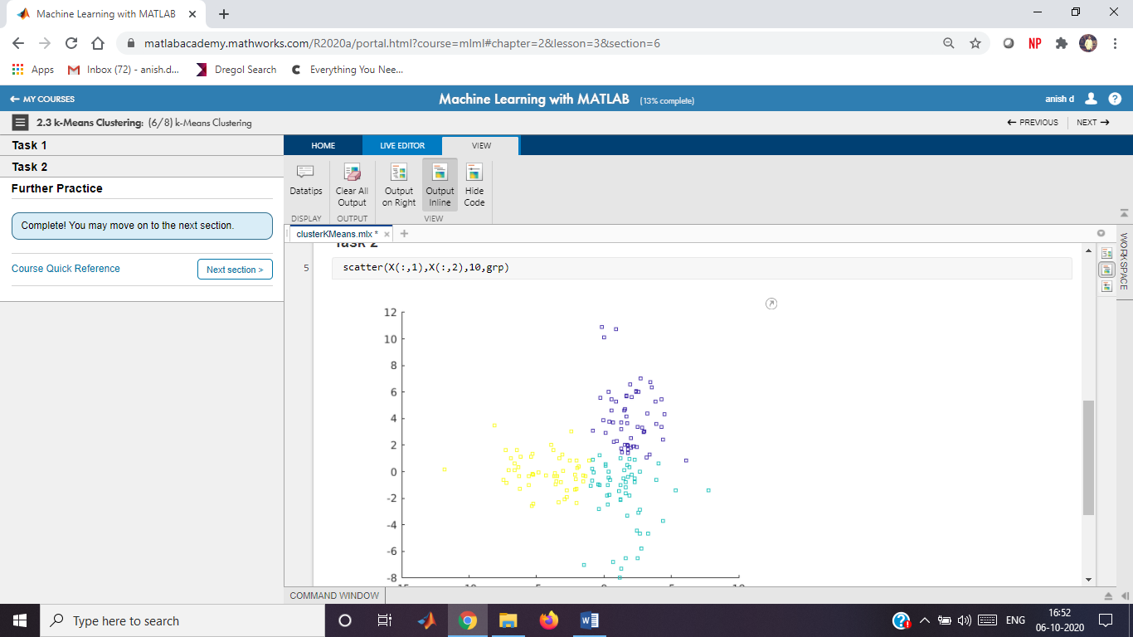

# Options for k-Means Clustering

Instructions are in the task pane to the left. Complete and submit each task one at a time.

This code loads and displays the data.

load rData

whos X

Name Size Bytes Class Attributes  
  
 X 217x2 3472 double

## **Task 1**

grp=kmeans(X,3)

grp = 217×1

3  
 3  
 3  
 3  
 3  
 1  
 1  
 3  
 1  
 1

## **Task 2**

grp=kmeans(X,3,"Start","cluster","Replicates",5)

grp = 217×1

2  
 1  
 1  
 1  
 1  
 2  
 2  
 1  
 2  
 2

This code plots the data by group.

scatter(X(:,1),X(:,2),15,grp)

-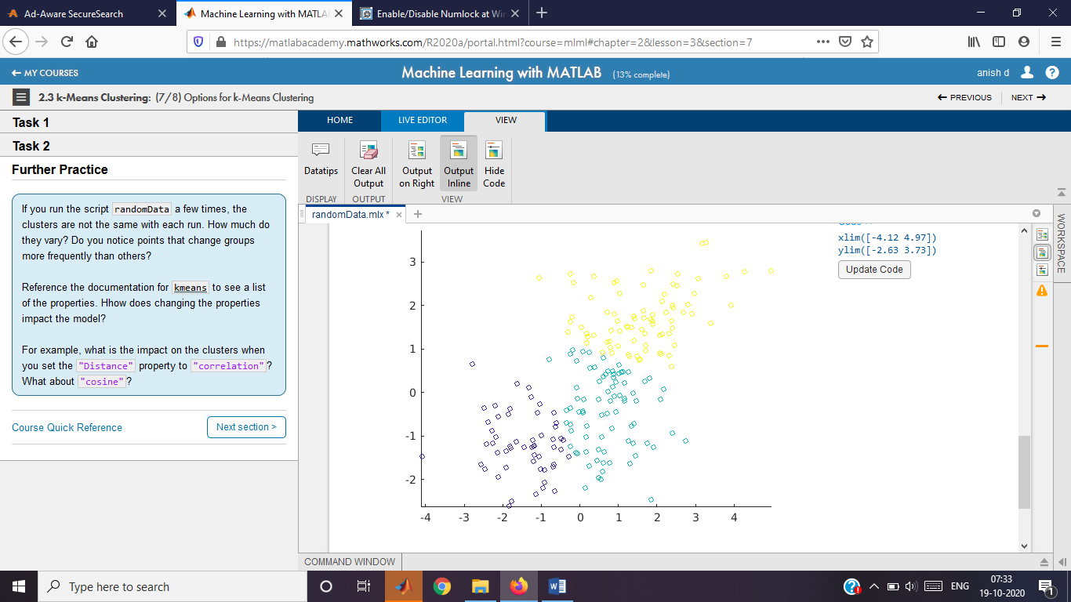

# Basketball Players

Instructions are in the task pane to the left. Complete and submit each task one at a time.

This code loads and formats the data.

data = readtable("bball.txt");

data.pos = categorical(data.pos);

This code extracts and normalizes the columns of interest.

stats = data{:,[5 6 11:end]};

statsNorm = normalize(stats);

## **Task 1**

grp=kmeans(statsNorm,2,"Replicates",5)

This code performs PCA and plots the transformed data by group.

[pcs,scrs] = pca(statsNorm);

scatter3(scrs(:,1),scrs(:,2),scrs(:,3),10,grp)

view(110,40)

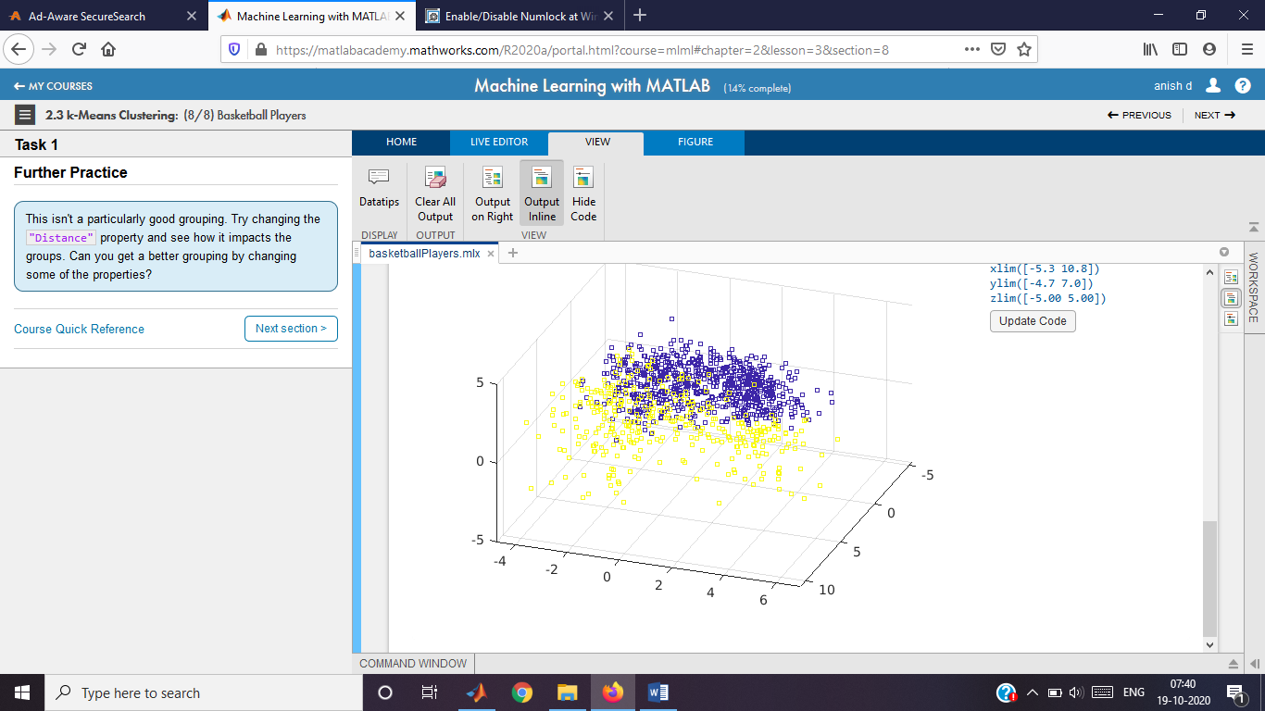

Gaussian Mixture Models

Instructions are in the task pane to the left. Complete and submit each task one at a time.

This code loads and displays the data.

load data;

whos X;

Name Size Bytes Class Attributes  
  
 X 154x2 2464 double

**Tasks 1 & 4**

mdl=fitgmdist(X,3)

mdl =   
  
Gaussian mixture distribution with 3 components in 2 dimensions  
Component 1:  
Mixing proportion: 0.442779  
Mean: -2.5596 5.0668  
  
Component 2:  
Mixing proportion: 0.384481  
Mean: -2.2042 -4.1388  
  
Component 3:  
Mixing proportion: 0.172740  
Mean: 3.0404 -0.1552

mdl=fitgmdist(X,3,"CovarianceType","diagonal")

mdl =   
  
Gaussian mixture distribution with 3 components in 2 dimensions  
Component 1:  
Mixing proportion: 0.170351  
Mean: 3.0528 -0.1856  
  
Component 2:  
Mixing proportion: 0.451237  
Mean: -2.5086 4.9429  
  
Component 3:  
Mixing proportion: 0.378411  
Mean: -2.2295 -4.1579

**Task 2**

grp=cluster(mdl,X)

grp = 154×1

2  
 2  
 2  
 2  
 2  
 2  
 2  
 2  
 2  
 2

**Task 3**

scatter(X(:,1),X(:,2),10,grp)

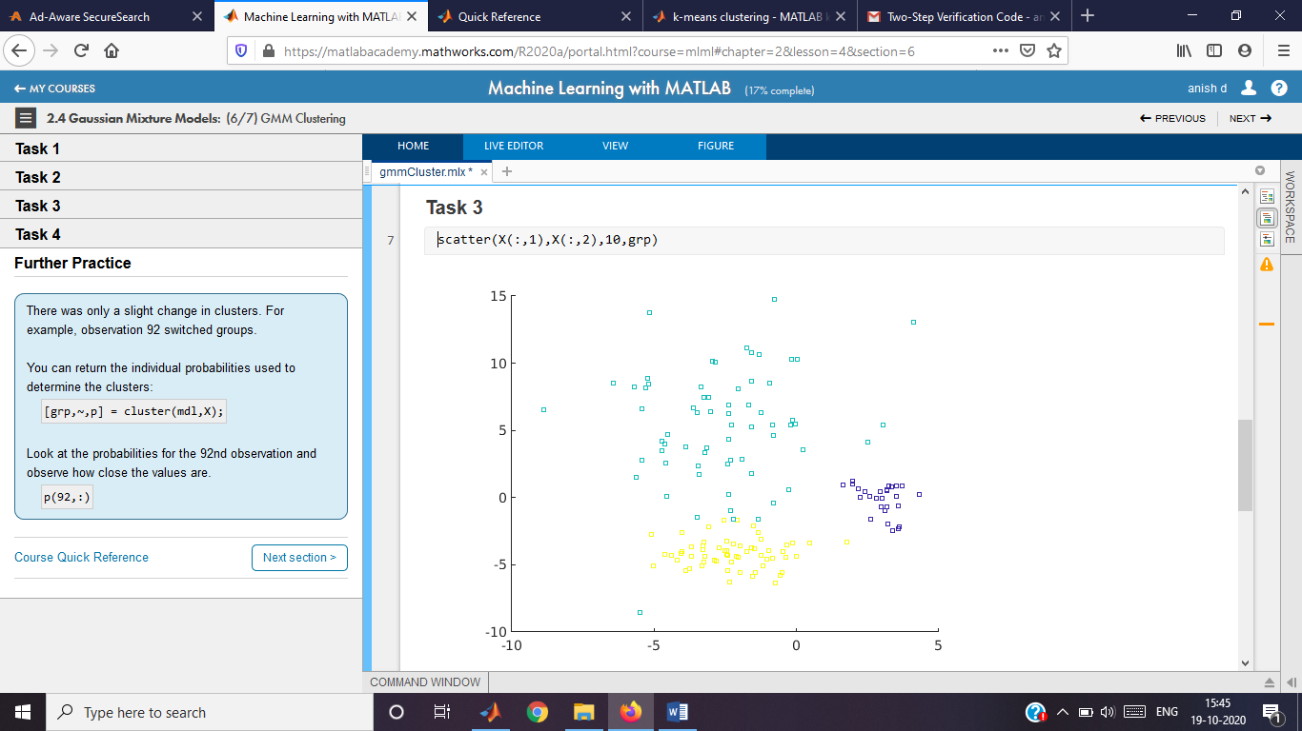

**Further Practice**

[grp,~,p]=cluster(mdl,X)

grp = 154×1

2  
 2  
 2  
 2  
 2  
 2  
 2  
 2  
 2  
 2

p = 154×3

0.0000 1.0000 0.0000  
 0.0000 1.0000 0.0000  
 0.0000 1.0000 0.0000  
 0.0000 1.0000 0.0000  
 0.0000 1.0000 0.0000  
 0.0000 1.0000 0.0000  
 0.0230 0.9770 0.0000  
 0.0000 1.0000 0.0000  
 0.0004 0.9996 0.0000  
 0.0000 1.0000 0.0000

p(92,:)

ans = 1×3

0.0000 0.5182 0.4818

Basketball Players

Instructions are in the task pane to the left. Complete and submit each task one at a time.

This code loads and formats the data.

data = readtable("bball.txt");

data.pos = categorical(data.pos);

This code extracts and normalizes the columns of interest.

stats = data{:,[5 6 11:end]};

statsNorm = normalize(stats);

**Task 1**

gmModel=fitgmdist(statsNorm,2,"Replicates",5,"RegularizationValue",0.02)

Warning: Failed to converge in 100 iterations during replicate 1 for gmdistribution with 2 components

gmModel =   
  
Gaussian mixture distribution with 2 components in 17 dimensions

[grp,~,gprob]=cluster(gmModel,statsNorm)

grp = 1117×1

1  
 2  
 1  
 1  
 1  
 2  
 1  
 2  
 2  
 2

gprob = 1117×2

0.9963 0.0037  
 0.0000 1.0000  
 0.8087 0.1913  
 0.9976 0.0024  
 0.9998 0.0002  
 0.0000 1.0000  
 0.7642 0.2358  
 0.0000 1.0000  
 0.1327 0.8673  
 0.0000 1.0000

This code performs PCA and plots the transformed data by group.

[pcs,scrs] = pca(statsNorm);

scatter3(scrs(:,1),scrs(:,2),scrs(:,3),10,grp)

view(110,40)

This code visualizes group separation.

gpsort = sortrows(gprob,1);

plot(gpsort)

xlabel("Point Ranking")

ylabel("Cluster Membership Probability")

legend("Cluster 1","Cluster 2")

# Parallel Coordinates

Instructions are in the task pane to the left. Complete and submit each task one at a time.

This code loads the data.

load data

whos X

Name Size Bytes Class Attributes  
  
 X 124x4 3968 double

## **Task 1**

[grp,C]=kmeans(X,3)

grp = 124×1

2  
 2  
 2  
 2  
 2  
 2  
 2  
 2  
 2  
 2

C = 3×4

3.0351 -0.1498 3.1239 0.1736  
 -2.7202 6.0202 -1.1364 -4.9812  
 -2.2648 -4.0838 -5.2336 1.0345

## **Task 2**

parallelcoords(X,"Group",grp)

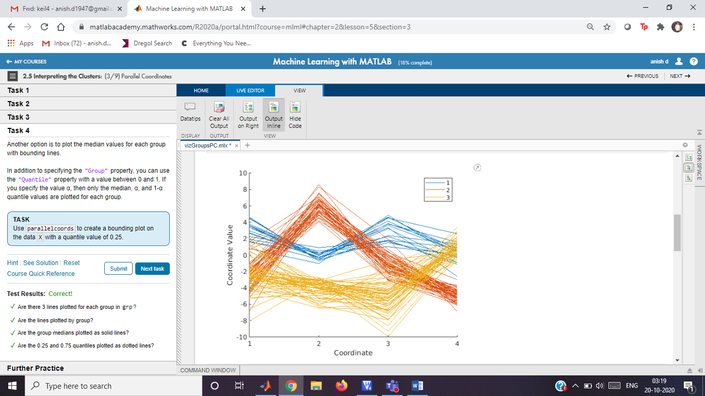

## **Task 3**

parallelcoords(C,"Group",1:3)

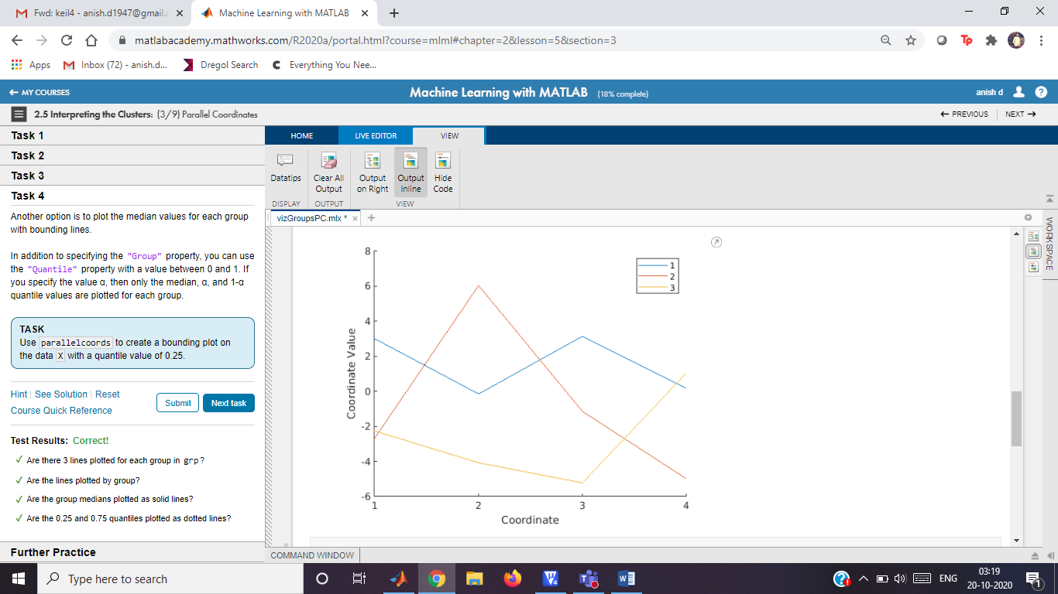

## **Task 4**

parallelcoords(X,"Group",grp,"Quantile",0.25)

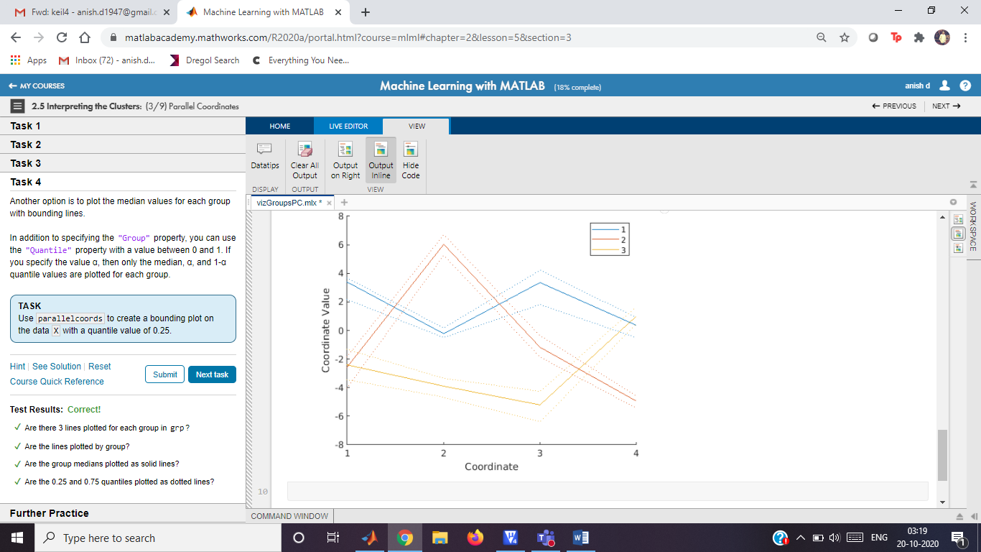

## **Further Practice**

# Cross-Tabulation

Instructions are in the task pane to the left. Complete and submit each task one at a time.

This code loads the data.

load data2

whos X yCat

Name Size Bytes Class Attributes  
  
 X 600x2 9600 double   
 yCat 600x1 818 categorical

This code clusters the data into 2 groups using kmeans and visualizes the clusters.

grp = kmeans(X,2);

scatter(X(:,1),X(:,2),15,grp)

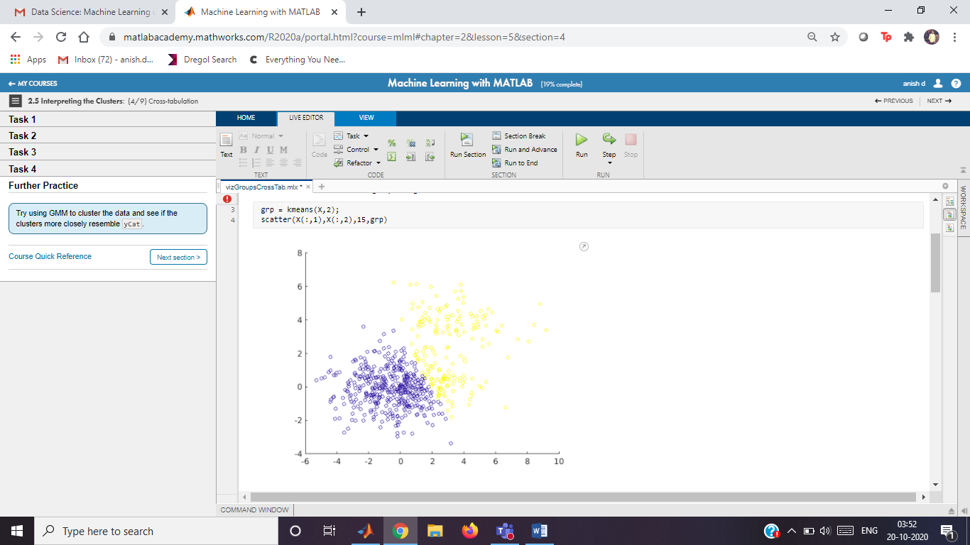

## **Task 1**

cts=crosstab(yCat,grp)

cts = 2×2

409 91  
 5 95

## **Task 2**

bar(cts,"stacked")

## **Task 3**

xticklabels(categories(yCat))

legend("1","2")

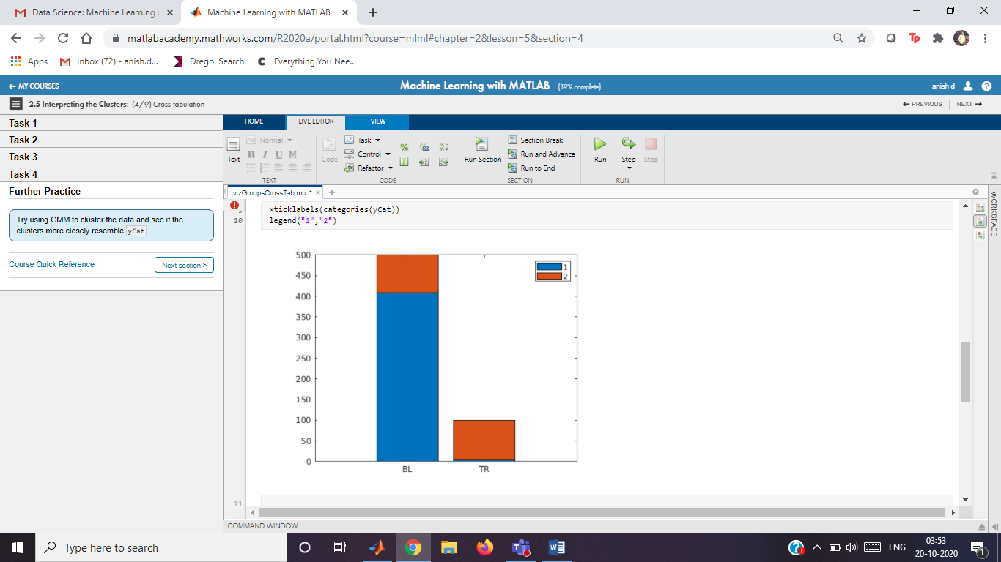

## **Task 4**

bar(cts',"stacked")

legend(categories(yCat))

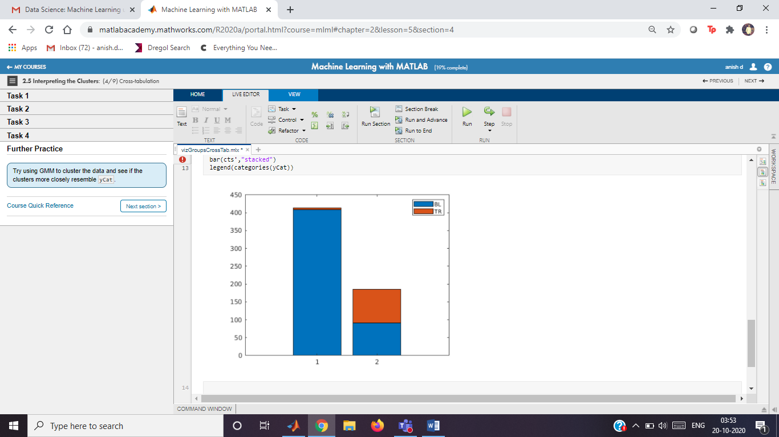

## **Further Practice**

cluster=fitgmmodel(yCat,3)

Unrecognized function or variable 'fitgmmodel'.

# Silhouette Plots

Instructions are in the task pane to the left. Complete and submit each task one at a time.

This code loads the data.

load data2

whos X yCat

Name Size Bytes Class Attributes  
  
 X 600x2 9600 double   
 yCat 600x1 818 categorical

This code clusters the data into 2 groups using kmeans.

grp = kmeans(X,2);

## **Task 1**

silhouette(X,grp)

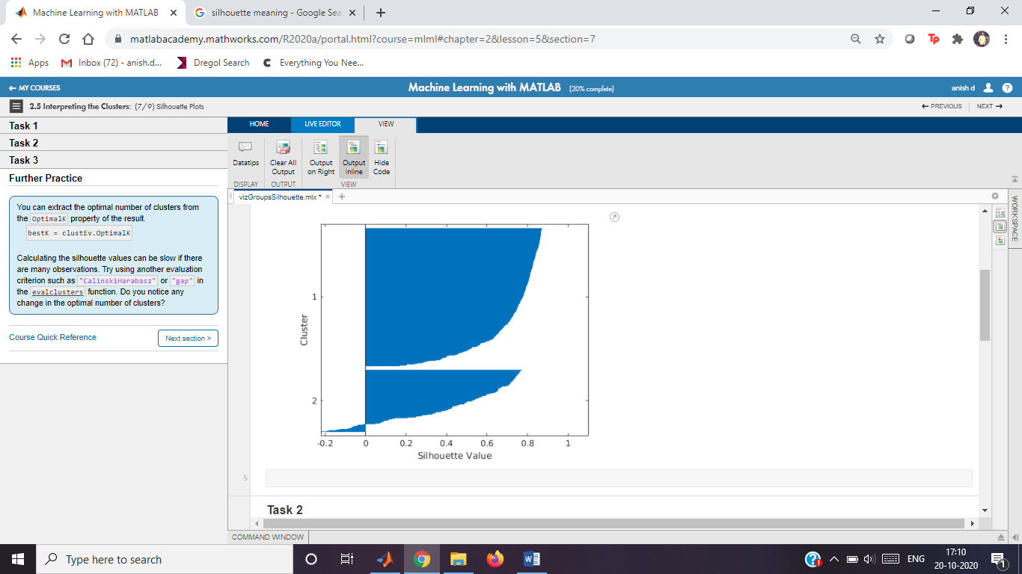

## **Task 2**

grp3=kmeans(X,3)

grp3 = 600×1

3  
 1  
 1  
 3  
 1  
 3  
 3  
 1  
 3  
 3

silhouette(X,grp3)

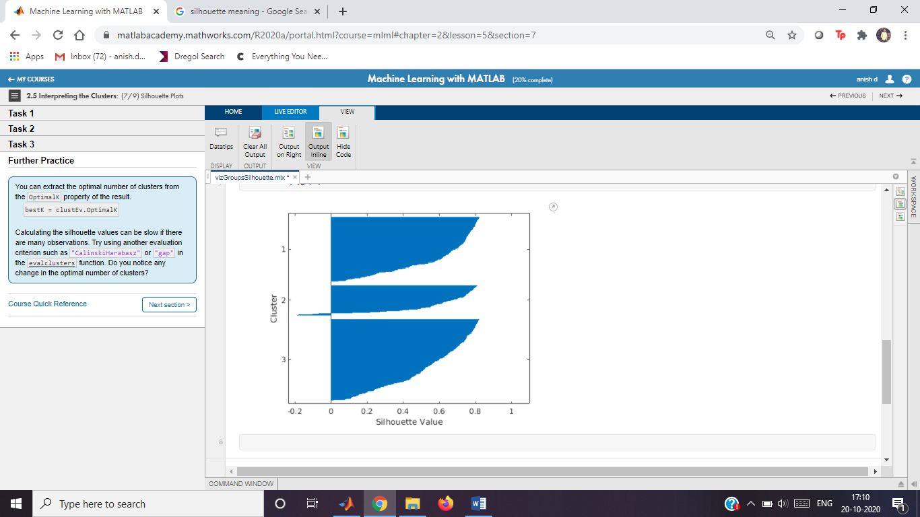

## **Task 3**

clustEv=evalclusters(X,"kmeans","silhouette","Klist",2:5)

clustEv =

SilhouetteEvaluation with properties:  
  
 NumObservations: 600  
 InspectedK: [2 3 4 5]  
 CriterionValues: [0.6354 0.5768 0.5148 0.5283]  
 OptimalK: 2

## **Further Practice**

bestK=clustEv.OptimalK

bestK = 2

# Basketball Players

Instructions are in the task pane to the left. Complete and submit each task one at a time.

This code loads, formats, and normalizes the data.

data = readtable("bball.txt");

data.pos = categorical(data.pos);

stats = data{:,[5 6 11:end]};

labels = data.Properties.VariableNames([5 6 11:end]);

statsNorm = normalize(stats);

This code groups the data using a Gaussian mixture model.

gmModel = fitgmdist(statsNorm,2,"Replicates",5,"RegularizationValue",0.02);

grp = cluster(gmModel,statsNorm);

## **Task 1**

counts=crosstab(data.pos,grp)

counts = 8×2

4 115  
 2 42  
 110 206  
 7 111  
 2 0  
 38 11  
 366 1  
 89 10

bar(counts,"stacked")

legend(string(1:2))

xticklabels(categories(data.pos))

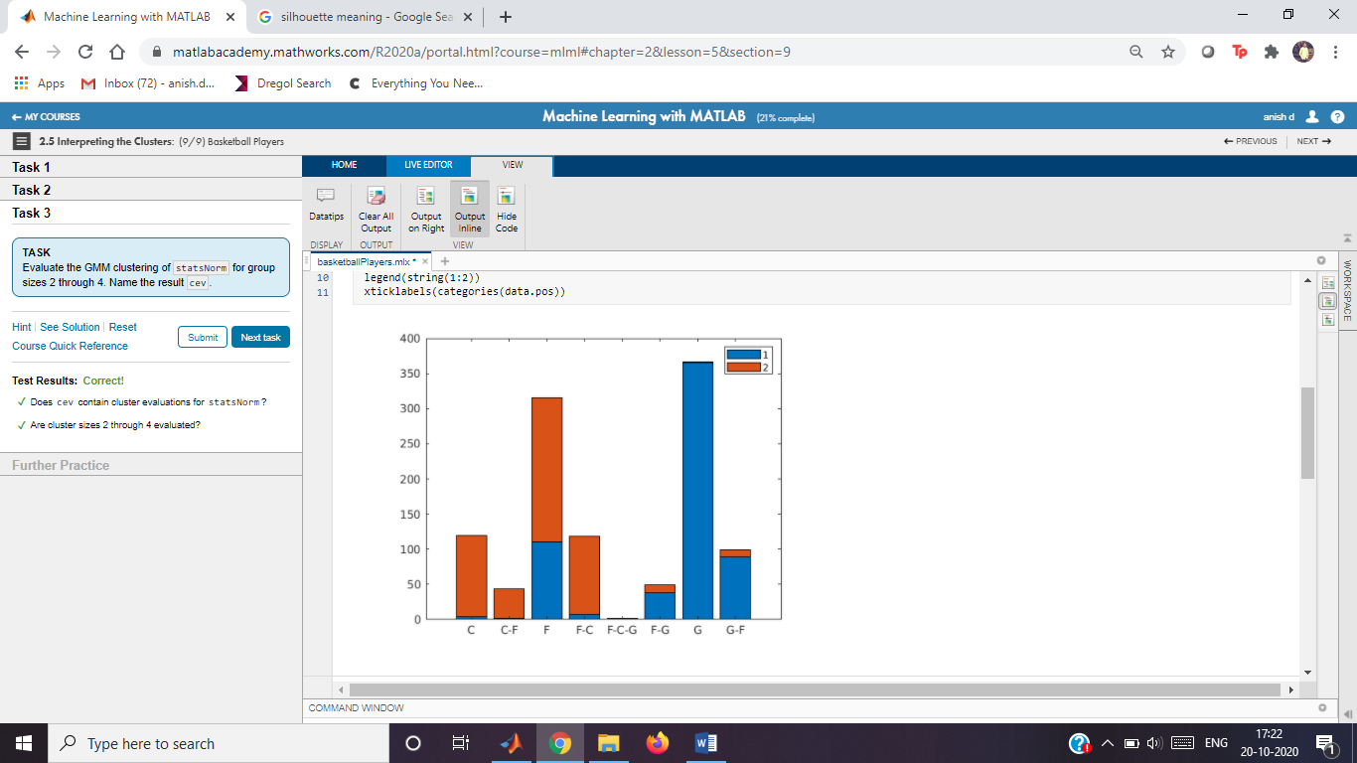

## **Task 2**

parallelcoords(gmModel.mu,"Group",1:2)

xticklabels(labels)

xtickangle(60)

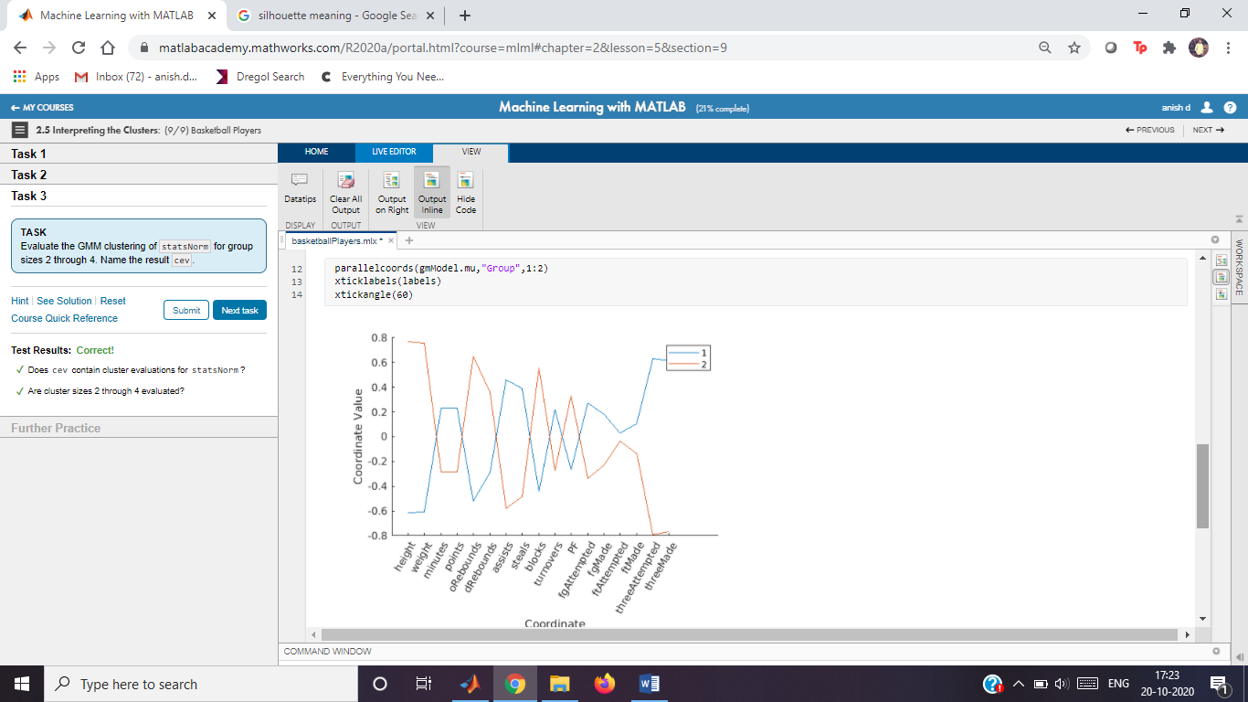

## **Task 3**

cev=evalclusters(statsNorm,"gmdistribution","DaviesBouldin","Klist",2:4)

Warning: Failed to converge in 100 iterations during replicate 5 for gmdistribution with 3 components

Warning: Failed to converge in 100 iterations during replicate 4 for gmdistribution with 4 components

cev =

DaviesBouldinEvaluation with properties:  
  
 NumObservations: 1117  
 InspectedK: [2 3 4]  
 CriterionValues: [1.0052 1.4527 1.3572]  
 OptimalK: 2

optK=cev.OptimalK

optK = 2

## **Further Practice**

Hierarchical Tree

Instructions are in the task pane to the left. Complete and submit each task one at a time.

This code loads the data.

load data

whos X

Name Size Bytes Class Attributes  
  
 X 124x4 3968 double

**Task 1**

Z=linkage(X)

Z = 123×3

43.0000 49.0000 0.4461  
 75.0000 104.0000 0.4839  
 58.0000 107.0000 0.4987  
 60.0000 77.0000 0.5282  
 81.0000 97.0000 0.5393  
 10.0000 18.0000 0.5517  
 5.0000 34.0000 0.5743  
 19.0000 42.0000 0.5966  
 21.0000 36.0000 0.6059  
 125.0000 131.0000 0.6123

**Task 2**

dendrogram(Z)

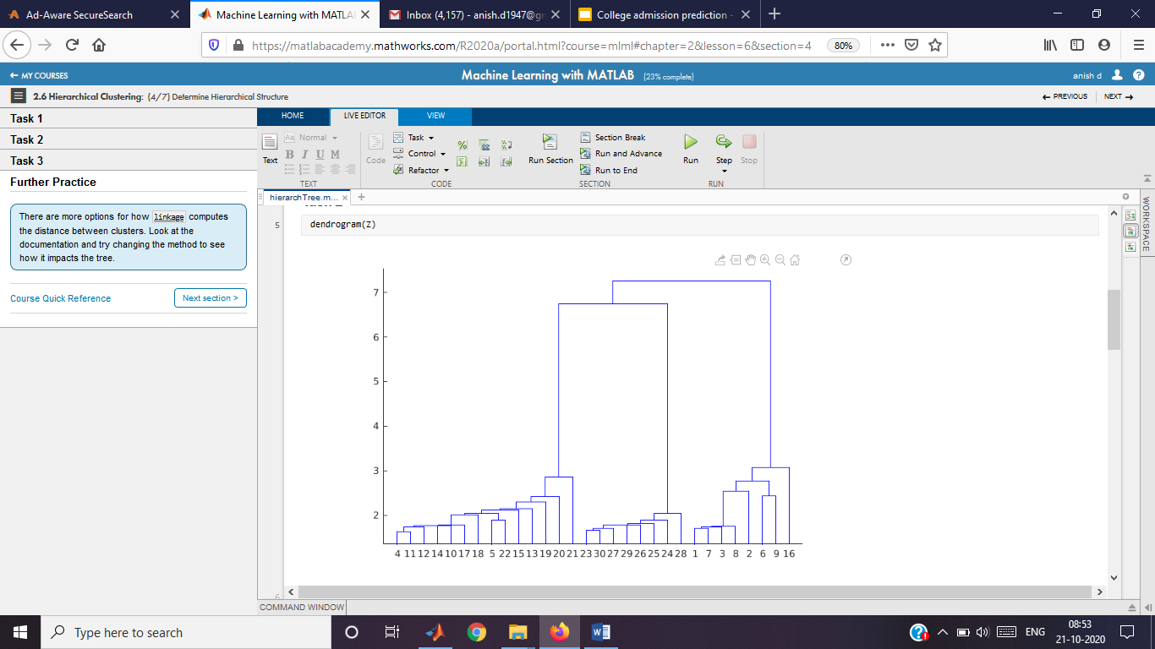

**Task 3**

Zcomp=linkage(X,"ward")

Zcomp = 123×3

43.0000 49.0000 0.4461  
 75.0000 104.0000 0.4839  
 58.0000 107.0000 0.4987  
 60.0000 77.0000 0.5282  
 81.0000 97.0000 0.5393  
 10.0000 18.0000 0.5517  
 5.0000 34.0000 0.5743  
 19.0000 42.0000 0.5966  
 21.0000 36.0000 0.6059  
 35.0000 51.0000 0.6213

dendrogram(Zcomp)

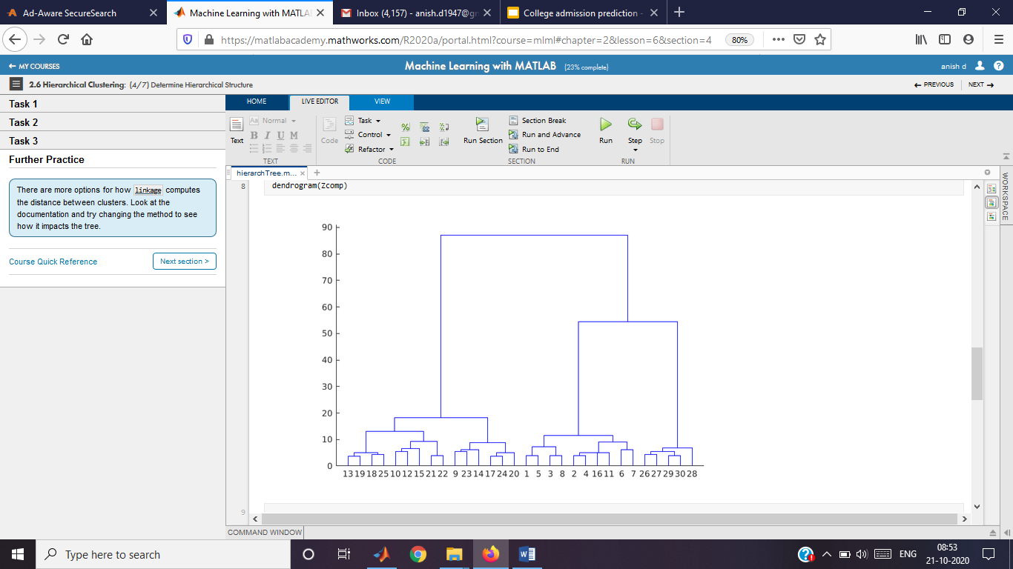

**Further Practice**

Zcomp2=linkage(X,"median")

Warning: Non-monotonic cluster tree -- the median linkage is probably not appropriate.

Zcomp2 = 123×3

43.0000 49.0000 0.4461  
 75.0000 104.0000 0.4839  
 58.0000 107.0000 0.4987  
 60.0000 77.0000 0.5282  
 81.0000 97.0000 0.5393  
 10.0000 18.0000 0.5517  
 5.0000 34.0000 0.5743  
 19.0000 42.0000 0.5966  
 21.0000 36.0000 0.6059  
 35.0000 51.0000 0.6213

dendrogram(Zcomp2)

Hierarchical Clustering

Instructions are in the task pane to the left. Complete and submit each task one at a time.

This code loads the data.

load data

whos X

Name Size Bytes Class Attributes  
  
 X 124x4 3968 double

This code creates a tree of hierarchical clusters.

Z = linkage(X);

dendrogram(Z)

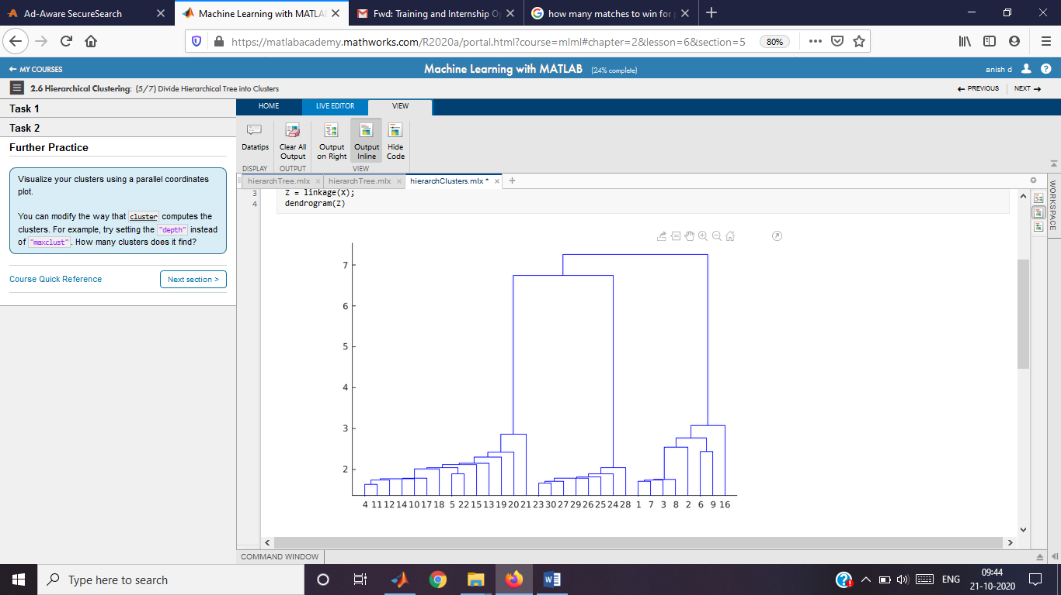

**Task 1**

grp=cluster(Z,"maxclust",3)

grp = 124×1

3  
 3  
 3  
 3  
 3  
 3  
 3  
 3  
 3  
 3

**Task 2**

Y=pdist(X)

Y = 1×7626

2.6056 3.2384 2.8874 0.8845 4.0136 2.7352 4.3374 3.4797 2.0891 2.1367 2.0517 2.4830 1.9490 1.5463 4.4767 1.8080 2.2917 2.8750 1.3134 1.3775 2.3632 1.4813 1.8872 2.1680 1.2320 2.5871 1.0661 3.0201 3.4046 2.4217 5.2930 2.3377 1.3094 2.1754 1.5251 3.5664 1.8041 1.7505 2.9649 2.0748 2.5062 1.2323 2.9339 1.8009 2.1460 1.7115 2.6073 1.2464 3.3412 2.7424

c=cophenet(Z,Y)

c = 0.9389

**Further Practice**

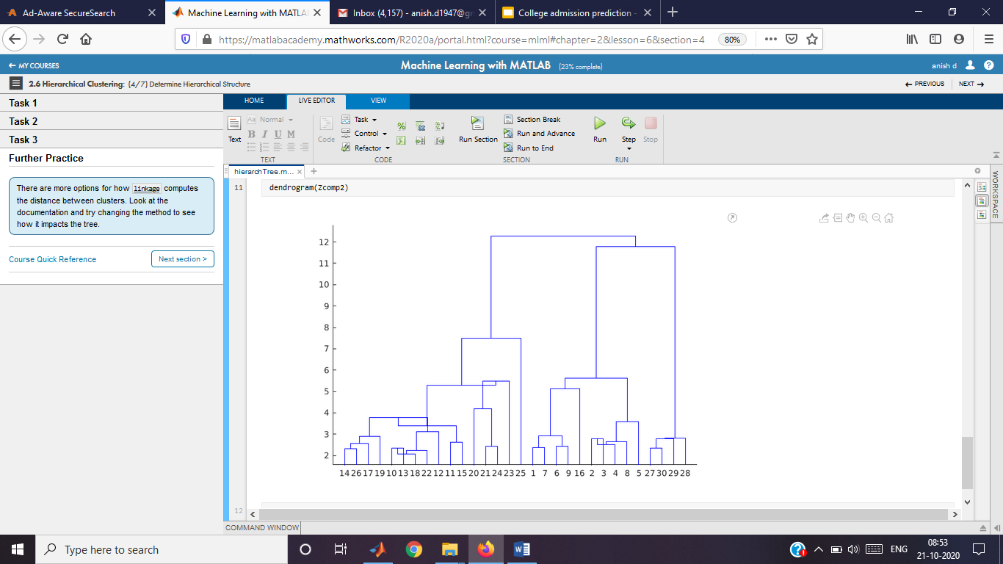

# Basketball Players

Instructions are in the task pane to the left. Complete and submit each task one at a time.

This code loads, formats, and normalizes the data.

data = readtable("bball.txt");

data.pos = categorical(data.pos);

stats = data{:,[5 6 11:end]};

labels = data.Properties.VariableNames([5 6 11:end]);

statsNorm = normalize(stats);

This code extracts the data for the guard position (G).

posStats = statsNorm(data.pos == "G",:);

## **Task 1**

Z=linkage(posStats,"ward");

gc2=cluster(Z,"maxclust",2);

gc3=cluster(Z,"maxclust",3);

This code visualizes the clusters.

parallelcoords(posStats,"Group",gc2,"Quantile",0.25,"Labels",labels)

xtickangle(60)

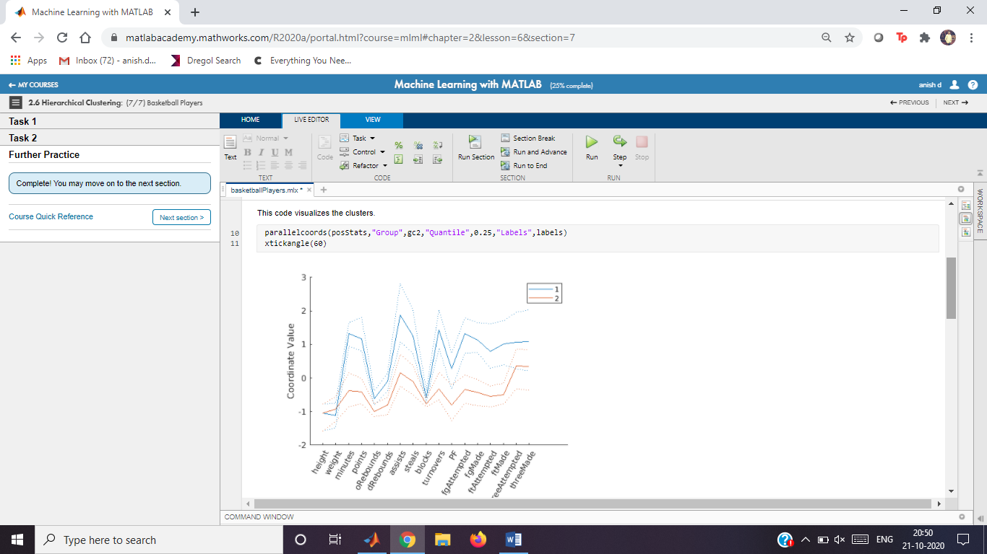

parallelcoords(posStats,"Group",gc3,"Quantile",0.25,"Labels",labels)

xtickangle(60)

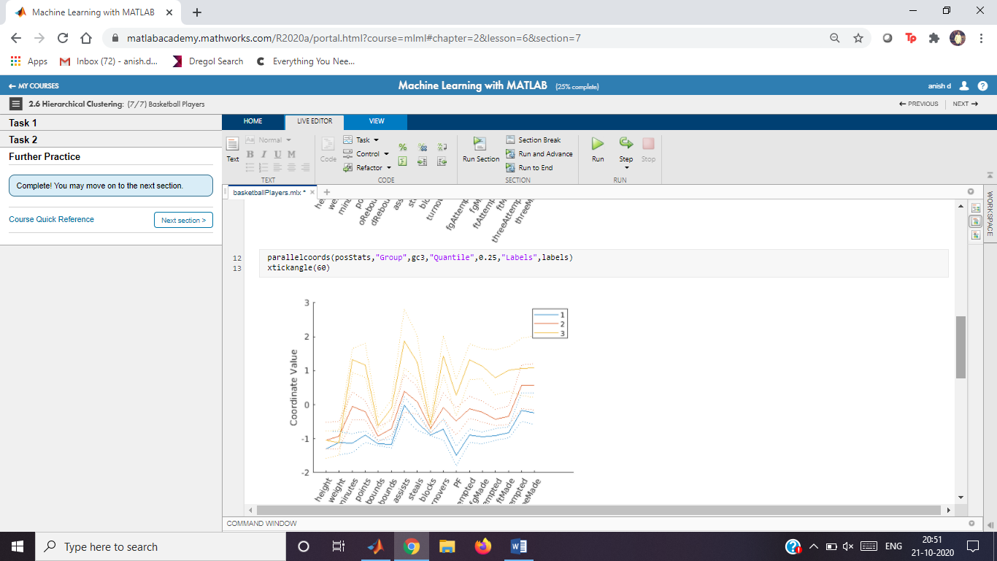

## **Task 2**

dendrogram(Z)

ec=evalclusters(posStats,"linkage","silhouette","KList",2:8)

ec =

SilhouetteEvaluation with properties:  
  
 NumObservations: 367  
 InspectedK: [2 3 4 5 6 7 8]  
 CriterionValues: [0.5960 0.2794 0.2641 0.2348 0.2423 0.2516 0.2523]  
 OptimalK: 2

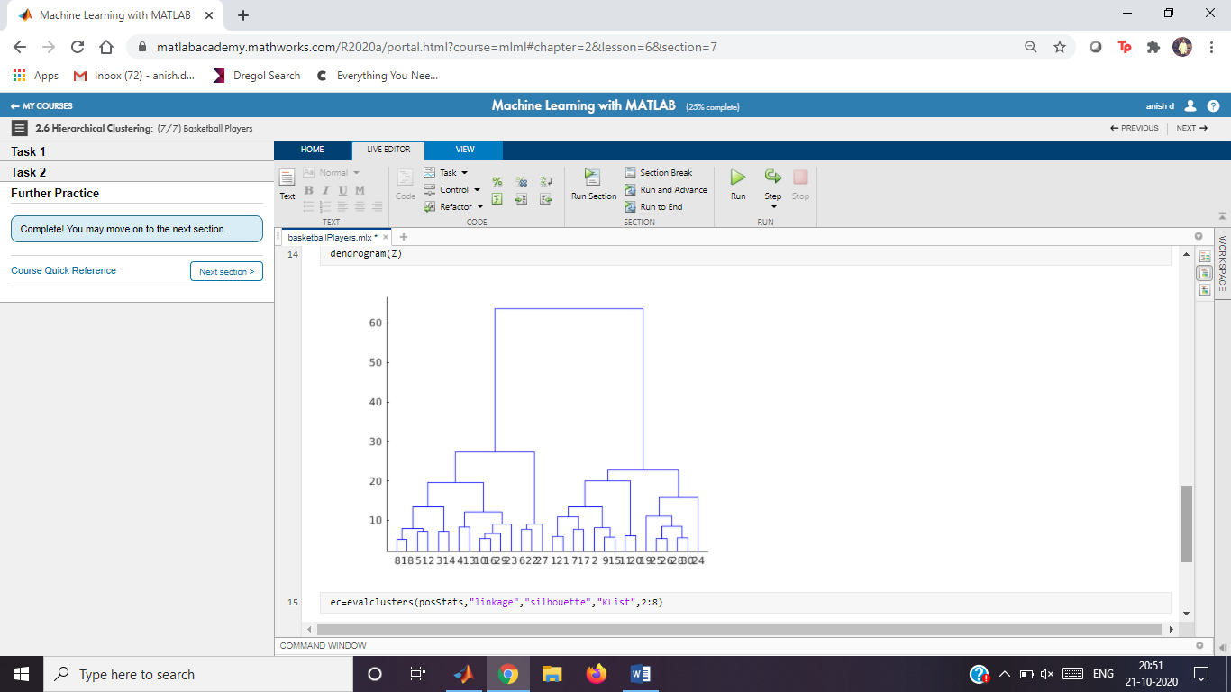

# Wine Color

Instructions are in the task pane to the left. Complete and submit each task one at a time.

This code loads and formats the data.

wineData = readtable("wineData.txt");

wineData.Color = categorical(wineData.Color);

This code extracts the numeric data.

numData = wineData{:,1:end-1};

## **Task 1**

[pcs,scrs,~,~,pexp]=pca(numData)

pcs = 12×12

-0.0072 -0.0074 -0.0104 0.0229 0.9321 0.3532 0.0367 -0.0137 -0.0532 -0.0367 -0.0022 -0.0010  
 -0.0012 -0.0015 -0.0042 0.0001 0.0086 -0.0043 0.6219 -0.4474 0.2669 0.5821 -0.0535 -0.0019  
 0.0005 0.0000 0.0014 0.0021 0.0441 0.0332 -0.4042 0.4823 0.0597 0.7726 -0.0229 0.0000  
 0.0415 0.0244 -0.0295 0.9949 -0.0500 0.0668 0.0063 0.0040 -0.0022 -0.0017 0.0005 -0.0004  
 -0.0001 -0.0000 -0.0007 0.0001 0.0069 -0.0063 0.0353 0.0044 0.0317 0.0427 0.9978 -0.0112  
 0.2265 0.9434 -0.2390 -0.0397 0.0060 0.0040 0.0002 -0.0007 0.0001 0.0003 -0.0001 0.0000  
 0.9731 -0.2194 0.0618 -0.0334 0.0057 0.0040 0.0017 -0.0002 0.0000 -0.0001 0.0001 0.0000  
 0.0000 -0.0000 -0.0001 0.0004 0.0013 -0.0009 0.0051 0.0029 -0.0004 0.0012 0.0109 0.9999  
 -0.0007 0.0005 0.0001 -0.0072 -0.0399 -0.0267 0.5855 0.4972 -0.6366 0.0484 -0.0047 -0.0047  
 -0.0007 0.0004 0.0005 -0.0017 0.0273 -0.0007 0.3225 0.5655 0.7184 -0.2421 -0.0266 -0.0025

scrs = 6448×12

-3.0678 9.3734 32.5977 -2.4215 0.2119 0.3934 0.0380 0.0127 -0.1646 0.1659 -0.0024 -0.0003  
 7.3196 3.5528 30.6864 5.8485 2.4961 -0.4909 0.0600 -0.0574 -0.1567 0.0507 -0.0176 -0.0008  
 8.7630 31.6443 22.8187 -1.7619 0.0640 0.5840 0.0944 -0.1783 -0.1257 0.1246 -0.0192 -0.0010  
 21.3467 -1.5987 29.3397 -3.4561 0.5879 0.4801 0.0748 -0.0397 -0.0934 0.0124 -0.0010 -0.0003  
 -31.6879 -4.8063 28.8603 -1.8581 -1.6234 -0.0601 0.7002 -0.0855 0.2121 0.1241 -0.0200 0.0004  
 -102.0967 5.1035 25.7605 2.3293 1.8636 -0.0173 -0.0522 0.2299 0.2191 0.0331 0.0074 0.0008  
 -19.7925 10.4066 24.9020 -1.9422 0.3044 -1.5507 0.0337 0.0748 0.0164 -0.0199 -0.0070 -0.0005  
 -11.5836 9.7293 25.0847 2.6223 -0.1091 0.2298 0.0545 0.0268 -0.1396 0.0269 -0.0078 -0.0010  
 -31.8849 7.1653 25.7654 -1.9709 -0.4641 -0.1079 0.1669 0.0354 -0.0144 0.0388 -0.0250 -0.0016  
 75.3687 12.9894 24.7293 -1.0703 0.6779 -0.3474 0.0733 -0.1096 -0.1476 0.0036 -0.0115 0.0006

pexp = 12×1

93.2478  
 3.9680  
 2.2542  
 0.4611  
 0.0420  
 0.0248  
 0.0009  
 0.0005  
 0.0004  
 0.0003

pareto(pexp)

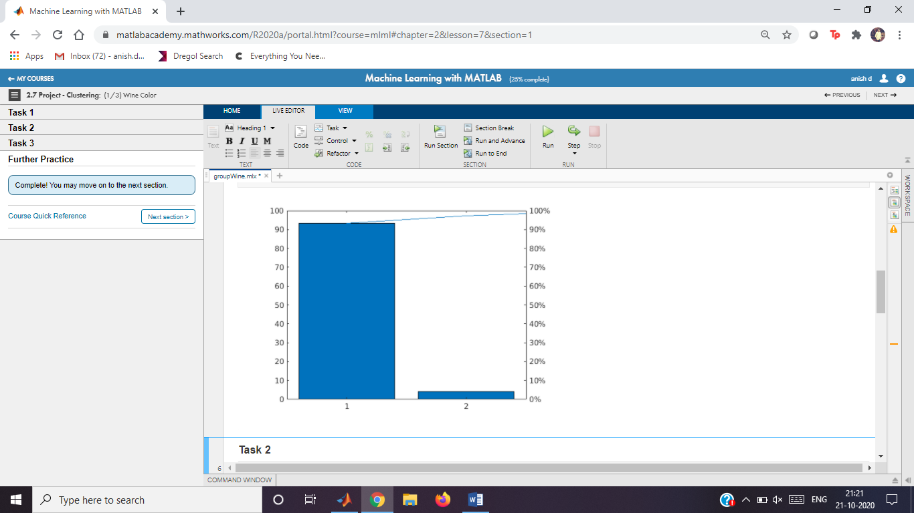

## **Task 2**

g=kmeans(numData,2,"Replicates",5);

gmModel=fitgmdist(numData,2,"Replicates",5);

g=cluster(gmModel,numData)

g = 6448×1

2  
 2  
 2  
 2  
 1  
 1  
 2  
 2  
 2  
 2

scatter(scrs(:,1),scrs(:,2),10,g)

## **Task 3**

cts = crosstab(wineData.Color,g)

cts = 2×2

1546 14  
 313 4575

bar(cts,"stacked")

xticklabels(categories(wineData.Color))

legend("1","2")

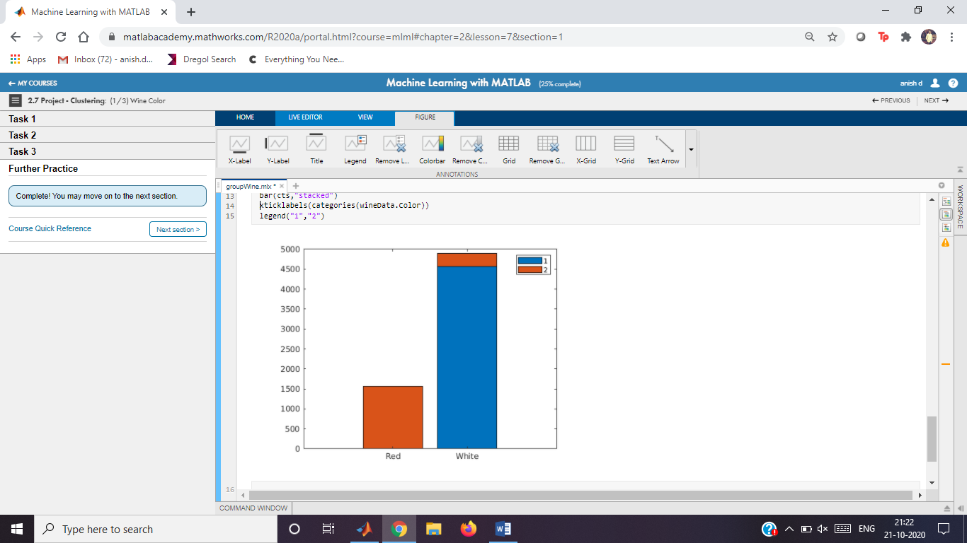

Corporate Bonds

Instructions are in the task pane to the left. Complete and submit each task one at a time.

This code loads the data and extracts the numeric data into a matrix.

bondData = readtable("bondData.txt");

bonds = bondData.Variables

bonds = 4082×4

5.6500 4.0240 4.5634 9.0000  
 6.2000 3.8030 5.0559 11.0000  
 1.6400 1.5540 1.6116 11.0000  
 10.2700 10.1930 25.3518 5.0000  
 5.8300 4.4790 5.1488 8.0000  
 6.4200 3.6750 4.7328 9.0000  
 6.7800 5.7730 6.4308 7.0000  
 6.5400 4.2420 5.7652 8.0000  
 3.3600 2.8020 3.2064 10.0000  
 7.2000 6.8750 7.1635 7.0000

**Task 1**

kGrp=kmeans(bonds,3,"Distance","cosine")

kGrp = 4082×1

3  
 3  
 2  
 1  
 3  
 3  
 1  
 3  
 2  
 1

**Task 2**

eva=evalclusters(kGrp,"kmeans","silhouette","Klist",2:7,"Distance","cosine")

eva =

SilhouetteEvaluation with properties:  
  
 NumObservations: 4082  
 InspectedK: [2 3 4 5 6 7]  
 CriterionValues: [NaN NaN NaN NaN NaN NaN]  
 OptimalK: NaN

**Further Practice**

silhouette(bonds,kGrp,"cosine")

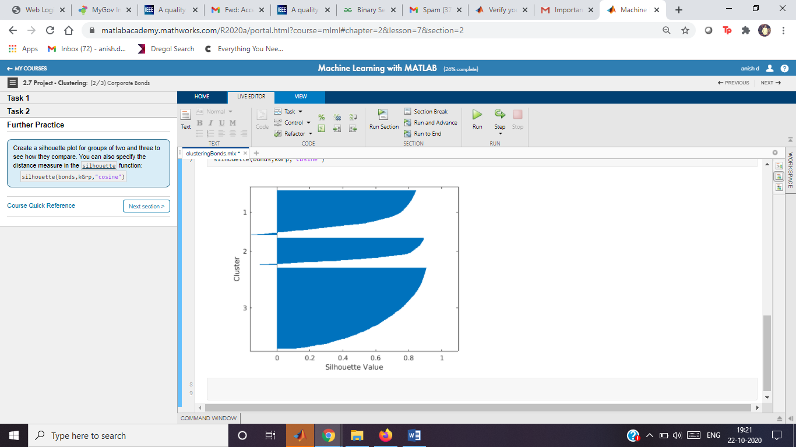

Wheat Seed Kernels

Instructions are in the task pane to the left. Complete and submit each task one at a time.

This code loads the data, then extracts the numeric data into a matrix and the existing group numbers into a vector.

data = readtable("seeds.txt");

numData = data{:,1:end-1}

numData = 210×7

15.2600 14.8400 0.8710 5.7630 3.3120 2.2210 5.2200  
 14.8800 14.5700 0.8811 5.5540 3.3330 1.0180 4.9560  
 14.2900 14.0900 0.9050 5.2910 3.3370 2.6990 4.8250  
 13.8400 13.9400 0.8955 5.3240 3.3790 2.2590 4.8050  
 16.1400 14.9900 0.9034 5.6580 3.5620 1.3550 5.1750  
 14.3800 14.2100 0.8951 5.3860 3.3120 2.4620 4.9560  
 14.6900 14.4900 0.8799 5.5630 3.2590 3.5860 5.2190  
 14.1100 14.1000 0.8911 5.4200 3.3020 2.7000 5.0000  
 16.6300 15.4600 0.8747 6.0530 3.4650 2.0400 5.8770  
 16.4400 15.2500 0.8880 5.8840 3.5050 1.9690 5.5330

variety = data.variety

variety = 210×1

1  
 1  
 1  
 1  
 1  
 1  
 1  
 1  
 1  
 1

**Task 1**

grpK=kmeans(numData,3)

grpK = 210×1

3  
 3  
 3  
 3  
 3  
 3  
 3  
 3  
 3  
 3

gmmodel=fitgmdist(numData,3)

gmmodel =   
  
Gaussian mixture distribution with 3 components in 7 dimensions

grpGMM=cluster(gmmodel,numData)

grpGMM = 210×1

3  
 3  
 3  
 3  
 2  
 3  
 3  
 3  
 2  
 2

Z=linkage(numData)

Z = 209×3

173.0000 207.0000 0.1174  
 149.0000 199.0000 0.1339  
 123.0000 134.0000 0.1358  
 8.0000 29.0000 0.1790  
 138.0000 139.0000 0.1914  
 35.0000 50.0000 0.2060  
 34.0000 68.0000 0.2076  
 201.0000 210.0000 0.2117  
 92.0000 93.0000 0.2120  
 22.0000 214.0000 0.2165

grpTree=cluster(Z,"maxclust",3)

grpTree = 210×1

2  
 2  
 2  
 2  
 2  
 2  
 2  
 2  
 2  
 2

Plot data by group using local function plotClusters.

plotClusters(numData,grpK,grpGMM,grpTree)

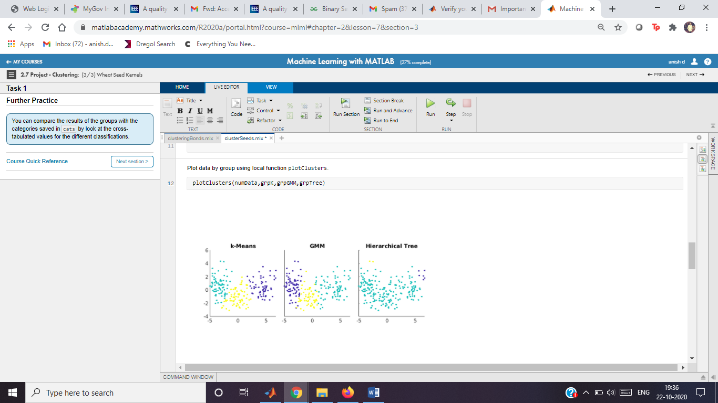

Plot cross-tabulation values using local function plotCrosstabs.

plotCrosstabs(variety,grpK,grpGMM,grpTree)

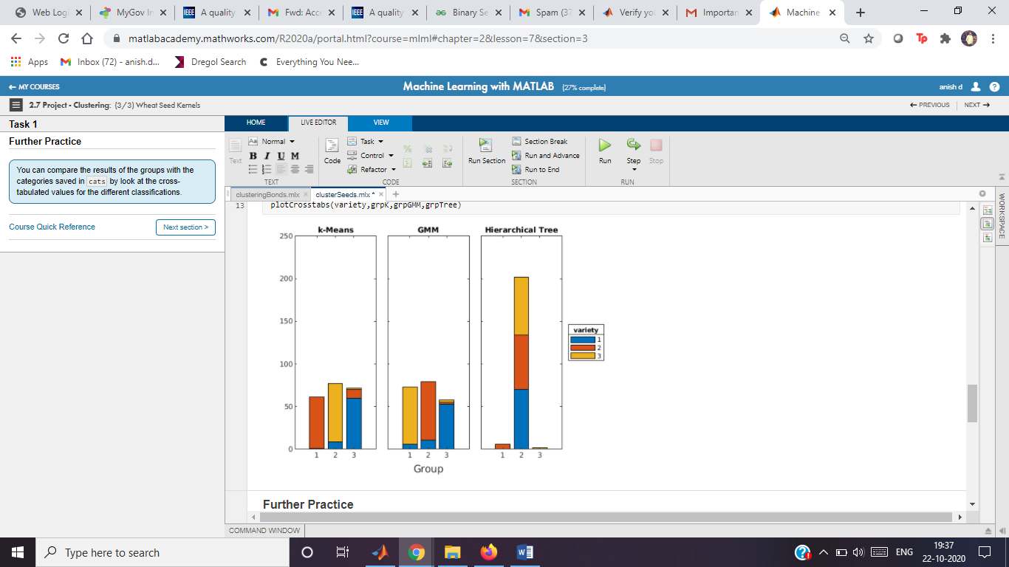

Corporate Bonds

Instructions are in the task pane to the left. Complete and submit each task one at a time.

This code loads the data and extracts the numeric data into a matrix.

bondData = readtable("bondData.txt");

bonds = bondData.Variables;

**Task 1**

kGrp = kmeans(bonds,3,"Distance","cosine");

silhouette(bonds,kGrp,"cosine")

**Task 2**

eva = evalclusters(bonds,"kmeans","silhouette",...

"KList",2:7,"Distance","cosine")

numClust = eva.OptimalK

kGrp = kmeans(bonds,numClust,"Distance","cosine");

silhouette(bonds,kGrp,"cosine")

**Further Practice**

classificationLearner()

**Further Practice**

This function creates side-by-side grouped scatter plots of the transformed data.

function plotClusters(data,gk,gm,gt)

[~,scrs] = pca(data);

sz = 8;

clf

tiledlayout(1,3,"TileSpacing","compact","Padding","compact");

ax(1) = nexttile;

scatter(scrs(:,1),scrs(:,2),sz,gk,"filled")

title("k-Means")

ax(2) = nexttile;

scatter(scrs(:,1),scrs(:,2),sz,gm,"filled")

title("GMM")

ax(3) = nexttile;

scatter(scrs(:,1),scrs(:,2),sz,gt,"filled")

title("Hierarchical Tree")

axis(ax,"square")

yticklabels(ax(2:end),[])

figure

end

This function creates side-by-side bar plots of the cross-tabluation values.

function plotCrosstabs(cats,gk,gm,gt)

clf

t = tiledlayout(1,3,"TileSpacing","compact","Padding","compact");

ax(1) = nexttile;

bar(crosstab(gk,cats),"stacked")

title("k-Means")

ax(2) = nexttile;

bar(crosstab(gm,cats),"stacked")

title("GMM")

ax(3) = nexttile;

bar(crosstab(gt,cats),"stacked")

title("Hierarchical Tree")

linkaxes(ax)

yticklabels(ax(2:end),[])

xlabel(t,"Group")

lgd = legend(string(1:3),"Location","eastoutside");

title(lgd,"variety")

figure

end

Nearest Neighbor Classification

Instructions are in the task pane to the left. Complete and submit each task one at a time.

This code loads and displays the data.

load groups

whos

Name Size Bytes Class Attributes  
  
 dataTest 32x3 2270 table   
 dataTrain 60x3 2746 table   
 err10 1x1 8 double   
 err3 1x1 8 double   
 groupData 92x3 3290 table   
 mdl 1x1 7030 ClassificationKNN   
 pg10 32x1 352 categorical   
 pg3 32x1 352 categorical   
 pg7 32x1 352 categorical

This code uses the local function plotGroup to plot the data by group.

clf

plotGroup(groupData,groupData.group,"x")

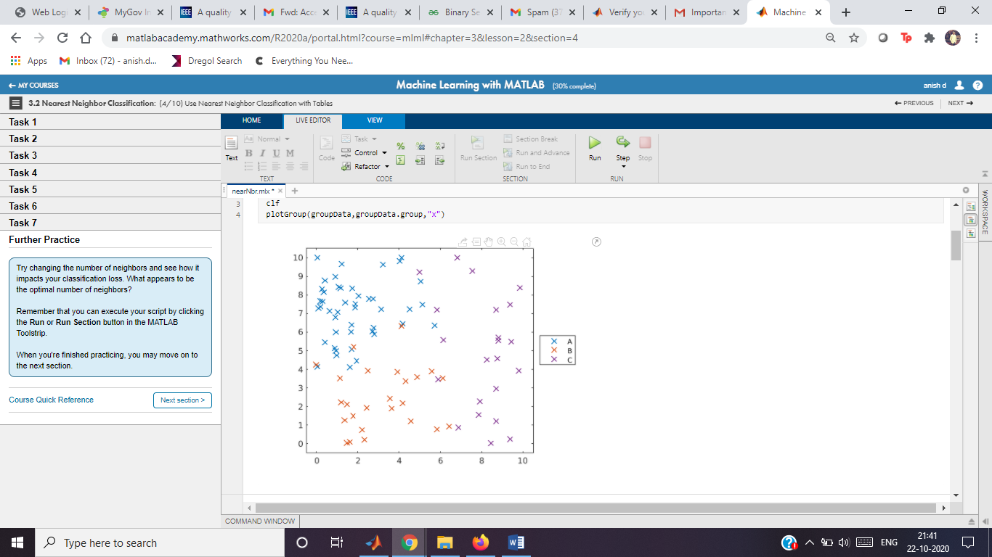

**Task 1**

mdl=fitcknn(dataTrain,"group","NumNeighbors",3)

mdl =

ClassificationKNN  
 PredictorNames: {'x' 'y'}  
 ResponseName: 'group'  
 CategoricalPredictors: []  
 ClassNames: [A B C]  
 ScoreTransform: 'none'  
 NumObservations: 60  
 Distance: 'euclidean'  
 NumNeighbors: 3  
  
  
 Properties, Methods

**Task 2**

pg3=predict(mdl,dataTest)

pg3 = 32×1 categorical

A   
A   
A   
A   
A   
A   
A   
A   
A   
B

**Task 3**

hold on

plotGroup(dataTest,pg3,"o")

hold off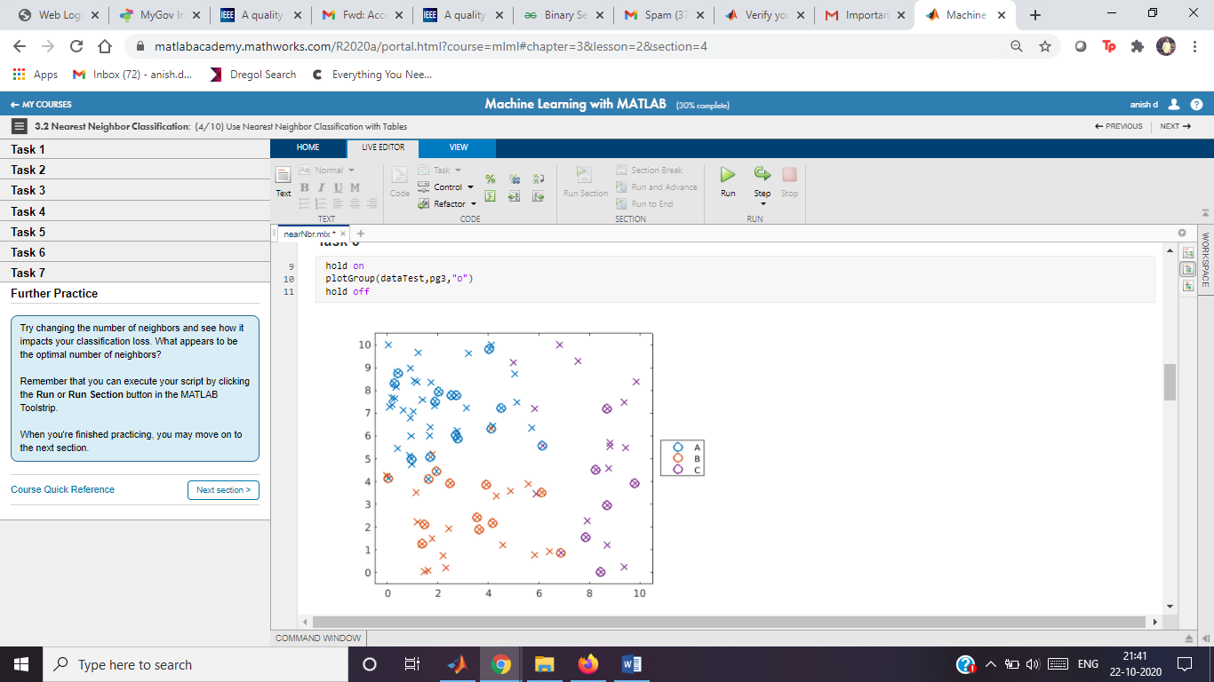

**Task 4**

err3 = loss(mdl,dataTest)

err3 = 0.1880

**Task 5**

mdl.NumNeighbors=10

mdl =

ClassificationKNN  
 PredictorNames: {'x' 'y'}  
 ResponseName: 'group'  
 CategoricalPredictors: []  
 ClassNames: [A B C]  
 ScoreTransform: 'none'  
 NumObservations: 60  
 Distance: 'euclidean'  
 NumNeighbors: 10  
  
  
 Properties, Methods

**Task 6**

pg10=predict(mdl,dataTest)

pg10 = 32×1 categorical

A   
A   
A   
A   
A   
A   
A   
A   
A   
A

hold on

plotGroup(dataTest,pg10,"p")

hold off

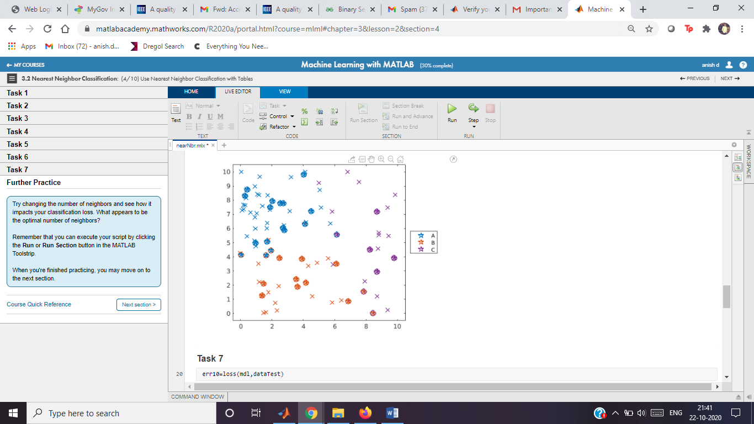

**Task 7**

err10=loss(mdl,dataTest)

err10 = 0.1171

**Further Practice**

mdl.NumNeighbors=7

mdl =

ClassificationKNN  
 PredictorNames: {'x' 'y'}  
 ResponseName: 'group'  
 CategoricalPredictors: []  
 ClassNames: [A B C]  
 ScoreTransform: 'none'  
 NumObservations: 60  
 Distance: 'euclidean'  
 NumNeighbors: 7  
  
  
 Properties, Methods

pg7=predict(mdl,dataTest)

pg7 = 32×1 categorical

A   
A   
A   
A   
A   
A   
A   
A   
A   
A

hold on

plotGroup(dataTest,pg7,"+")

hold off

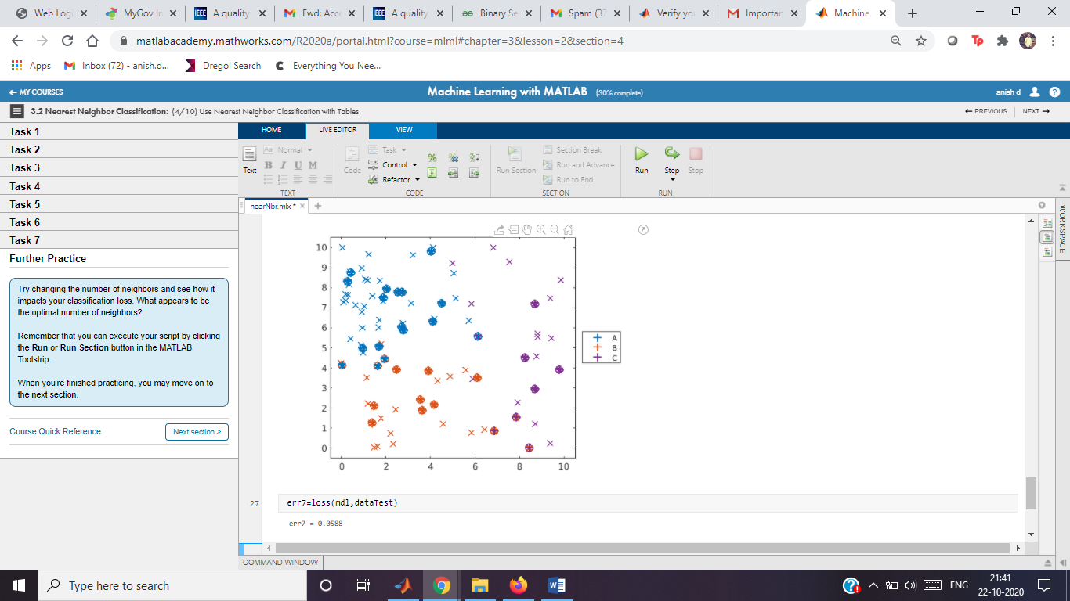

err7=loss(mdl,dataTest)

err7 = 0.0588

This function uses gscatter to create a formatted plot of grouped data.

function plotGroup(data,grp,mkr)

validateattributes(data,"table",{'nonempty','ncols',3})

% Plot data by group

colors = colororder;

p = gscatter(data.x,data.y,grp,colors([1 2 4],:),mkr,9);

% Format plot

[p.LineWidth] = deal(1.5);

legend("Location","eastoutside")

xlim([-0.5 10.5])

ylim([-0.5 10.5])

end

Heart Disease Analysis

Instructions are in the task pane to the left. Complete and submit each task one at a time.

This code loads the data.

heartData = readtable("heartDataNum.txt");

heartData.HeartDisease = categorical(heartData.HeartDisease);

This code partitions the data into training and test sets.

pt = cvpartition(heartData.HeartDisease,"HoldOut",0.3);

hdTrain = heartData(training(pt),:);

hdTest = heartData(test(pt),:);

**Task 1**

mdl = fitcknn(hdTrain,"HeartDisease");

**Task 2**

mdl.NumNeighbors=5

mdl =

ClassificationKNN  
 PredictorNames: {'Age' 'Cholesterol' 'ExerciseDuration' 'METs' 'RestingHeartRate' 'RestingSystolic' 'RestingDiastolic' 'MaxHeartRate' 'PeakExSystolic' 'PeakExDiastolic' 'InducedSTDep'}  
 ResponseName: 'HeartDisease'  
 CategoricalPredictors: []  
 ClassNames: [false true]  
 ScoreTransform: 'none'  
 NumObservations: 299  
 Distance: 'euclidean'  
 NumNeighbors: 5  
  
  
 Properties, Methods

**Task 3**

mdl.DistanceWeight="squaredinverse"

mdl =

ClassificationKNN  
 PredictorNames: {'Age' 'Cholesterol' 'ExerciseDuration' 'METs' 'RestingHeartRate' 'RestingSystolic' 'RestingDiastolic' 'MaxHeartRate' 'PeakExSystolic' 'PeakExDiastolic' 'InducedSTDep'}  
 ResponseName: 'HeartDisease'  
 CategoricalPredictors: []  
 ClassNames: [false true]  
 ScoreTransform: 'none'  
 NumObservations: 299  
 Distance: 'euclidean'  
 NumNeighbors: 5  
  
  
 Properties, Methods

Calculate the loss for the training and test sets

errTrain = resubLoss(mdl);

errTest = loss(mdl,hdTest);

disp("Training Error: " + errTrain)

Training Error: 0

disp("Test Error: " + errTest)

Test Error: 0.39873

# Classification Trees

Instructions are in the task pane to the left. Complete and submit each task one at a time.

This code loads, partitions, and plots the data.

load groups

rng(0)

cvpt = cvpartition(groupData.group,"Holdout",0.35);

dataTrain = groupData(training(cvpt),:);

dataTest = groupData(test(cvpt),:);

plotGroup(groupData,groupData.group,"x")

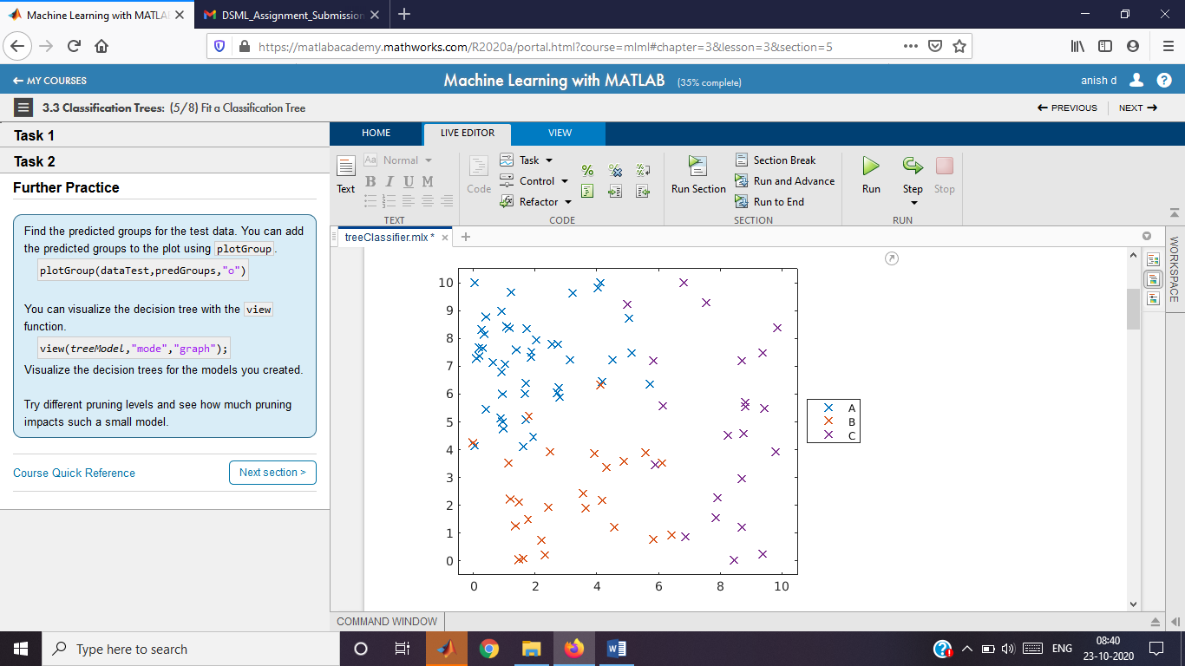

## **Task 1**

mdl=fitctree(dataTrain,"group")

Calculate loss.

errTree = loss(mdl,dataTest);

disp("Classification Tree Loss: " + errTree)

## **Task 2**

mdlPruned=prune(mdl,"level",1)

errPruned=loss(mdlPruned,dataTest)

## **Further Practice**

predGroups=predict(mdlPruned,dataTest)

plotGroup(dataTest,predGroups,"o")

view(mdlPruned,"mode","graph")

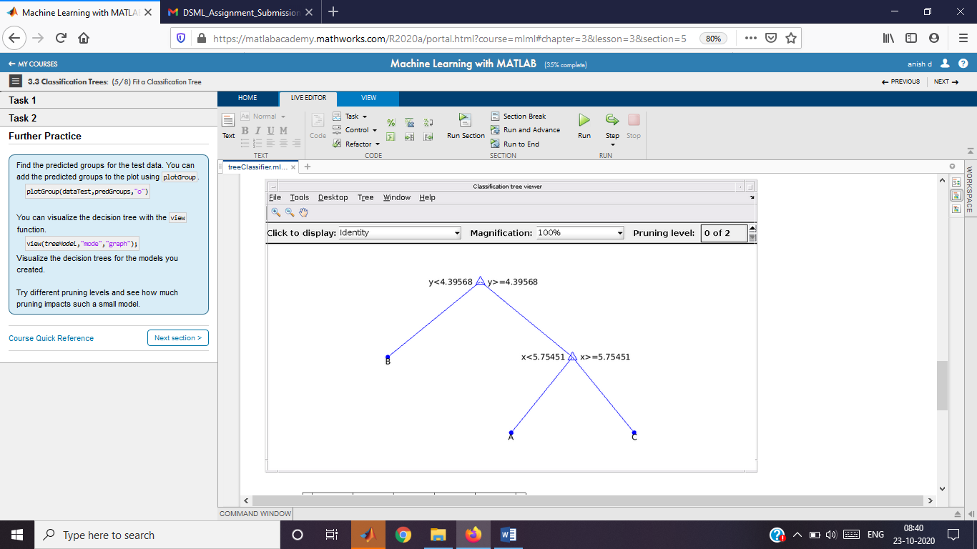

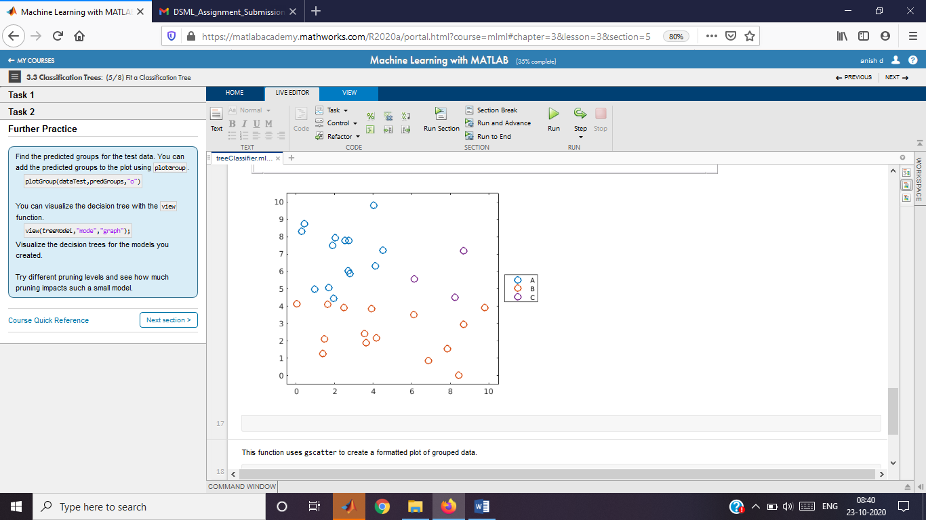

This function uses gscatter to create a formatted plot of grouped data.

function plotGroup(data,grp,mkr)

validateattributes(data,"table",{'nonempty','ncols',3})

% Plot data by group

colors = colororder;

p = gscatter(data.x,data.y,grp,colors([1 2 4],:),mkr,9);

% Format plot

[p.LineWidth] = deal(1.5);

legend("Location","eastoutside")

xlim([-0.5 10.5])

ylim([-0.5 10.5])

end

# Heart Disease Analysis (numeric data)

Instructions are in the task pane to the left. Complete and submit each task one at a time.

This code loads and formats the data.

heartData = readtable("heartDataNum.txt");

heartData.HeartDisease = categorical(heartData.HeartDisease);

This code partitions the data into training and test sets.

pt = cvpartition(heartData.HeartDisease,"HoldOut",0.3);

hdTrain = heartData(training(pt),:);

hdTest = heartData(test(pt),:);

## **Task 1**

mdl=fitctree(hdTrain,"HeartDisease")

mdl =

ClassificationTree  
 PredictorNames: {'Age' 'Cholesterol' 'ExerciseDuration' 'METs' 'RestingHeartRate' 'RestingSystolic' 'RestingDiastolic' 'MaxHeartRate' 'PeakExSystolic' 'PeakExDiastolic' 'InducedSTDep'}  
 ResponseName: 'HeartDisease'  
 CategoricalPredictors: []  
 ClassNames: [false true]  
 ScoreTransform: 'none'  
 NumObservations: 299  
  
  
 Properties, Methods

## **Task 2**

mdl=prune(mdl,"level",3)

mdl =

ClassificationTree  
 PredictorNames: {'Age' 'Cholesterol' 'ExerciseDuration' 'METs' 'RestingHeartRate' 'RestingSystolic' 'RestingDiastolic' 'MaxHeartRate' 'PeakExSystolic' 'PeakExDiastolic' 'InducedSTDep'}  
 ResponseName: 'HeartDisease'  
 CategoricalPredictors: []  
 ClassNames: [false true]  
 ScoreTransform: 'none'  
 NumObservations: 299  
  
  
 Properties, Methods

Calculate loss for training and test sets

errTrain = resubLoss(mdl);

errTest = loss(mdl,hdTest);

disp("Training Error: " + errTrain)

Training Error: 0.12709

disp("Test Error: " + errTest)

Test Error: 0.33554

# Heart Disease Analysis

Instructions are in the task pane to the left. Complete and submit each task one at a time.

This code loads and formats the data.

heartData = readtable("heartDataAll.txt");

heartData = convertvars(heartData,12:22,"categorical");

This code partitions the data into training and test sets.

pt = cvpartition(heartData.HeartDisease,"HoldOut",0.3);

hdTrain = heartData(training(pt),:);

hdTest = heartData(test(pt),:);

## **Task 1**

mdl=fitctree(hdTrain,"HeartDisease")

mdl =

ClassificationTree  
 PredictorNames: {1×21 cell}  
 ResponseName: 'HeartDisease'  
 CategoricalPredictors: [12 13 14 15 16 17 18 19 20 21]  
 ClassNames: [false true]  
 ScoreTransform: 'none'  
 NumObservations: 299  
  
  
 Properties, Methods

mdlpruned=prune(mdl,"level",3)

mdlpruned =

ClassificationTree  
 PredictorNames: {1×21 cell}  
 ResponseName: 'HeartDisease'  
 CategoricalPredictors: [12 13 14 15 16 17 18 19 20 21]  
 ClassNames: [false true]  
 ScoreTransform: 'none'  
 NumObservations: 299  
  
  
 Properties, Methods

mdlloss=loss(mdl,hdTrain)

mdlloss = 0.0702

mdlprunedLoss=loss(mdl,hdTrain)

mdlprunedLoss = 0.0702

Calculate loss for training and test sets

errTrain = resubLoss(mdl);

errTest = loss(mdl,hdTest);

disp("Training Error: " + errTrain)

Training Error: 0.070234

disp("Test Error: " + errTest)

Test Error: 0.36005

# Naive Bayes Classification

Instructions are in the task pane to the left. Complete and submit each task one at a time.

This code loads, partitions, and plots the data.

load groups

rng(0)

pt = cvpartition(groupData.group,"Holdout",0.35);

dataTrain = groupData(training(pt),:);

dataTest = groupData(test(pt),:);

plotGroup(groupData,groupData.group,"x")

## **Tasks 1 & 2**

mdlNB=fitcnb(dataTrain,"group")

mdlNB =

ClassificationNaiveBayes  
 PredictorNames: {'x' 'y'}  
 ResponseName: 'group'  
 CategoricalPredictors: []  
 ClassNames: [A B C]  
 ScoreTransform: 'none'  
 NumObservations: 60  
 DistributionNames: {'normal' 'normal'}  
 DistributionParameters: {3×2 cell}  
  
  
 Properties, Methods

mdlNB=fitcnb(dataTrain,"group","DistributionNames","kernel")

mdlNB =

ClassificationNaiveBayes  
 PredictorNames: {'x' 'y'}  
 ResponseName: 'group'  
 CategoricalPredictors: []  
 ClassNames: [A B C]  
 ScoreTransform: 'none'  
 NumObservations: 60  
 DistributionNames: {'kernel' 'kernel'}  
 DistributionParameters: {3×2 cell}  
 Kernel: {'normal' 'normal'}  
 Support: {'unbounded' 'unbounded'}  
 Width: [3×2 double]  
  
  
 Properties, Methods

Predict response and calculate loss.

predGroups = predict(mdlNB,dataTest);

errSVM = loss(mdlNB,dataTest);

disp("Naive Bayes Loss: " + errSVM)

Naive Bayes Loss: 0.12546

Plot predictions.

hold on

plotGroup(dataTest,predGroups,"o")

hold off

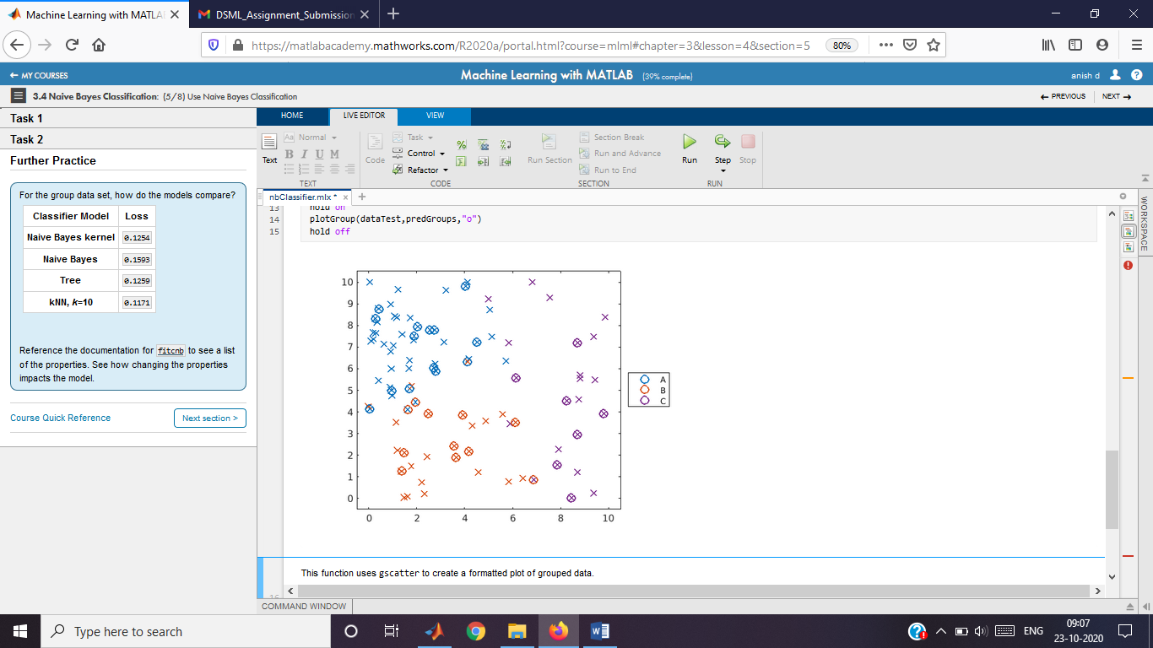

This function uses gscatter to create a formatted plot of grouped data.

function plotGroup(data,grp,mkr)

validateattributes(data,"table",{'nonempty','ncols',3})

% Plot data by group

colors = colororder;

p = gscatter(data.x,data.y,grp,colors([1 2 4],:),mkr,9);

% Format plot

[p.LineWidth] = deal(1.5);

legend("Location","eastoutside")

xlim([-0.5 10.5])

ylim([-0.5 10.5])

end

# Heart Disease Analysis (numeric data)

Instructions are in the task pane to the left. Complete and submit each task one at a time.

This code loads and formats the data.

heartData = readtable("heartDataNum.txt");

heartData.HeartDisease = categorical(heartData.HeartDisease);

This code partitions the data into training and test sets.

pt = cvpartition(heartData.HeartDisease,"HoldOut",0.3);

hdTrain = heartData(training(pt),:);

hdTest = heartData(test(pt),:);

## **Tasks 1 & 2**

mdl=fitcnb(hdTrain,"HeartDisease")

mdl =

ClassificationNaiveBayes  
 PredictorNames: {'Age' 'Cholesterol' 'ExerciseDuration' 'METs' 'RestingHeartRate' 'RestingSystolic' 'RestingDiastolic' 'MaxHeartRate' 'PeakExSystolic' 'PeakExDiastolic' 'InducedSTDep'}  
 ResponseName: 'HeartDisease'  
 CategoricalPredictors: []  
 ClassNames: [false true]  
 ScoreTransform: 'none'  
 NumObservations: 299  
 DistributionNames: {'normal' 'normal' 'normal' 'normal' 'normal' 'normal' 'normal' 'normal' 'normal' 'normal' 'normal'}  
 DistributionParameters: {2×11 cell}  
  
  
 Properties, Methods

mdl=fitcnb(hdTrain,"HeartDisease","DistributionName","Kernel")

mdl =

ClassificationNaiveBayes  
 PredictorNames: {'Age' 'Cholesterol' 'ExerciseDuration' 'METs' 'RestingHeartRate' 'RestingSystolic' 'RestingDiastolic' 'MaxHeartRate' 'PeakExSystolic' 'PeakExDiastolic' 'InducedSTDep'}  
 ResponseName: 'HeartDisease'  
 CategoricalPredictors: []  
 ClassNames: [false true]  
 ScoreTransform: 'none'  
 NumObservations: 299  
 DistributionNames: {'kernel' 'kernel' 'kernel' 'kernel' 'kernel' 'kernel' 'kernel' 'kernel' 'kernel' 'kernel' 'kernel'}  
 DistributionParameters: {2×11 cell}  
 Kernel: {'normal' 'normal' 'normal' 'normal' 'normal' 'normal' 'normal' 'normal' 'normal' 'normal' 'normal'}  
 Support: {'unbounded' 'unbounded' 'unbounded' 'unbounded' 'unbounded' 'unbounded' 'unbounded' 'unbounded' 'unbounded' 'unbounded' 'unbounded'}  
 Width: [2×11 double]  
  
  
 Properties, Methods

Calculate the loss for the training and test sets

errTrain = resubLoss(mdl);

errTest = loss(mdl,hdTest);

disp("Training Error: " + errTrain)

Training Error: 0.20736

disp("Test Error: " + errTest)

Test Error: 0.35996

# Heart Disease Analysis

Instructions are in the task pane to the left. Complete and submit each task one at a time.

This code loads and formats the data.

heartData = readtable("heartDataAll.txt");

heartData = convertvars(heartData,12:22,"categorical");

This code partitions the data into training and test sets.

pt = cvpartition(heartData.HeartDisease,"HoldOut",0.3);

hdTrain = heartData(training(pt),:);

hdTest = heartData(test(pt),:);

## **Tasks 1 & 2**

dists = [repmat("kernel",1,11) repmat("mvmn",1,10)]

dists = 1×21 string

"kernel" "kernel" "kernel" "kernel" "kernel" "kernel" "kernel" "kernel" "kernel" "kernel" "kernel" "mvmn" "mvmn" "mvmn" "mvmn" "mvmn" "mvmn" "mvmn" "mvmn" "mvmn" "mvmn"

mdl = fitcnb(hdTrain,"HeartDisease","DistributionNames",dists)

mdl =

ClassificationNaiveBayes  
 PredictorNames: {1×21 cell}  
 ResponseName: 'HeartDisease'  
 CategoricalPredictors: [12 13 14 15 16 17 18 19 20 21]  
 ClassNames: [false true]  
 ScoreTransform: 'none'  
 NumObservations: 299  
 DistributionNames: {'kernel' 'kernel' 'kernel' 'kernel' 'kernel' 'kernel' 'kernel' 'kernel' 'kernel' 'kernel' 'kernel' 'mvmn' 'mvmn' 'mvmn' 'mvmn' 'mvmn' 'mvmn' 'mvmn' 'mvmn' 'mvmn' 'mvmn'}  
 DistributionParameters: {2×21 cell}  
 CategoricalLevels: {[] [] [] [] [] [] [] [] [] [] [] [2×1 double] [4×1 double] [2×1 double] [3×1 double] [2×1 double] [2×1 double] [2×1 double] [2×1 double] [2×1 double] [3×1 double]}  
 Kernel: {'normal' 'normal' 'normal' 'normal' 'normal' 'normal' 'normal' 'normal' 'normal' 'normal' 'normal' [] [] [] [] [] [] [] [] [] []}  
 Support: {'unbounded' 'unbounded' 'unbounded' 'unbounded' 'unbounded' 'unbounded' 'unbounded' 'unbounded' 'unbounded' 'unbounded' 'unbounded' [] [] [] [] [] [] [] [] [] []}  
 Width: [2×21 double]  
  
  
 Properties, Methods

Calculate the loss for the training and test sets

errTrain = resubLoss(mdl);

errTest = loss(mdl,hdTest);

disp("Training Error: " + errTrain)

Training Error: 0.20401

disp("Test Error: " + errTest)

Test Error: 0.17958

# Discriminant Analysis

Instructions are in the task pane to the left. Complete and submit each task one at a time.

This code loads and partitions the data.

load groups

rng(0)

cvpt = cvpartition(groupData.group,"Holdout",0.35);

dataTrain = groupData(training(cvpt),:);

dataTest = groupData(test(cvpt),:);

plotGroup(groupData,groupData.group,"x")

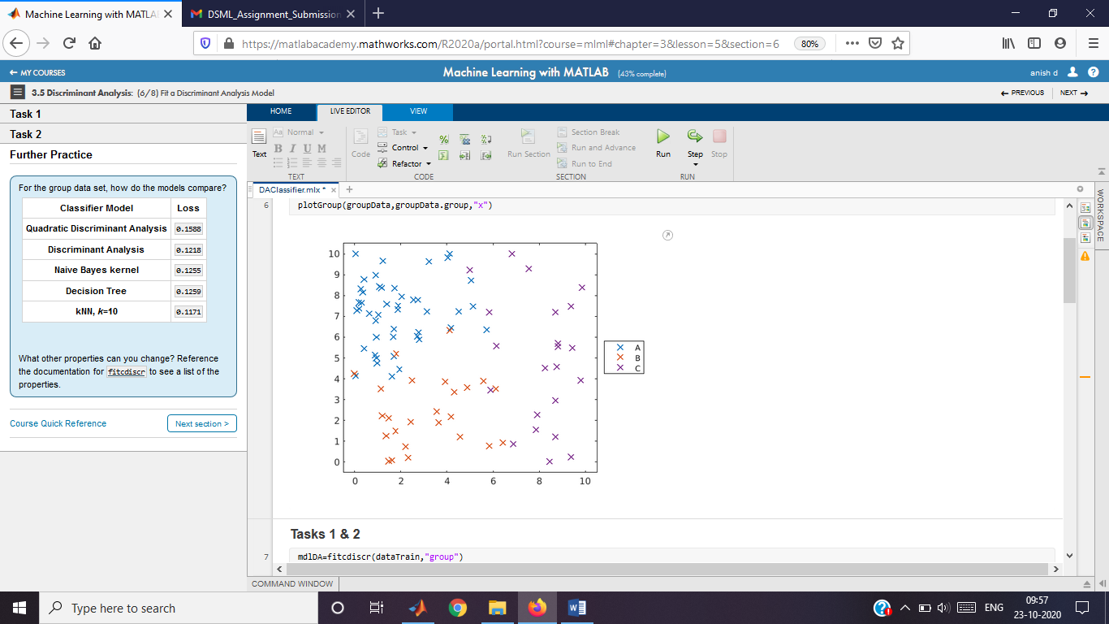

## **Tasks 1 & 2**

mdlDA=fitcdiscr(dataTrain,"group")

mdlDA =

ClassificationDiscriminant  
 PredictorNames: {'x' 'y'}  
 ResponseName: 'group'  
 CategoricalPredictors: []  
 ClassNames: [A B C]  
 ScoreTransform: 'none'  
 NumObservations: 60  
 DiscrimType: 'linear'  
 Mu: [3×2 double]  
 Coeffs: [3×3 struct]  
  
  
 Properties, Methods

predGroups=predict(mdlDA,dataTest)

predGroups = 32×1 categorical

A   
A   
A   
A   
A   
A   
A   
A   
A   
A

mdlDA=fitcdiscr(dataTrain,"group","DiscrimType","quadratic")

mdlDA =

ClassificationDiscriminant  
 PredictorNames: {'x' 'y'}  
 ResponseName: 'group'  
 CategoricalPredictors: []  
 ClassNames: [A B C]  
 ScoreTransform: 'none'  
 NumObservations: 60  
 DiscrimType: 'quadratic'  
 Mu: [3×2 double]  
 Coeffs: [3×3 struct]  
  
  
 Properties, Methods

predGroups=predict(mdlDA,dataTest)

predGroups = 32×1 categorical

A   
A   
A   
A   
A   
A   
A   
A   
A   
B

Calculate loss and plot predictions.

errDA = loss(mdlDA,dataTest);

disp("Discriminant Aanalysis Loss: " + errDA)

Discriminant Aanalysis Loss: 0.1588

hold on

plotGroup(dataTest,predGroups,"o")

hold off

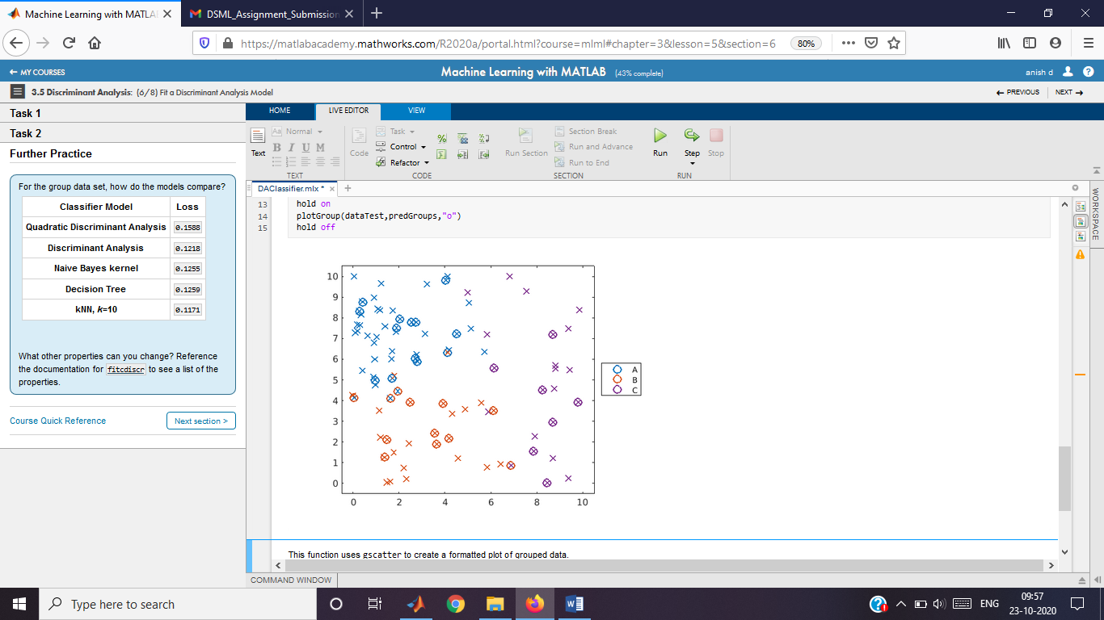

This function uses gscatter to create a formatted plot of grouped data.

function plotGroup(data,grp,mkr)

validateattributes(data,"table",{'nonempty','ncols',3})

% Plot data by group

colors = colororder;

p = gscatter(data.x,data.y,grp,colors([1 2 4],:),mkr,9);

% Format plot

[p.LineWidth] = deal(1.5);

legend("Location","eastoutside")

xlim([-0.5 10.5])

ylim([-0.5 10.5])

end

# Heart Disease Analysis (numeric data)

Instructions are in the task pane to the left. Complete and submit each task one at a time.

This code loads and formats the data.

heartData = readtable("heartDataNum.txt");

heartData.HeartDisease = categorical(heartData.HeartDisease);

This code partitions the data into training and test sets.

pt = cvpartition(heartData.HeartDisease,"HoldOut",0.3);

hdTrain = heartData(training(pt),:);

hdTest = heartData(test(pt),:);

## **Tasks 1 & 2**

mdl=fitcdiscr(hdTrain,"HeartDisease")

mdl =

ClassificationDiscriminant  
 PredictorNames: {'Age' 'Cholesterol' 'ExerciseDuration' 'METs' 'RestingHeartRate' 'RestingSystolic' 'RestingDiastolic' 'MaxHeartRate' 'PeakExSystolic' 'PeakExDiastolic' 'InducedSTDep'}  
 ResponseName: 'HeartDisease'  
 CategoricalPredictors: []  
 ClassNames: [false true]  
 ScoreTransform: 'none'  
 NumObservations: 299  
 DiscrimType: 'linear'  
 Mu: [2×11 double]  
 Coeffs: [2×2 struct]  
  
  
 Properties, Methods

mdl=fitcdiscr(hdTrain,"HeartDisease","DiscrimType","quadratic")

mdl =

ClassificationDiscriminant  
 PredictorNames: {'Age' 'Cholesterol' 'ExerciseDuration' 'METs' 'RestingHeartRate' 'RestingSystolic' 'RestingDiastolic' 'MaxHeartRate' 'PeakExSystolic' 'PeakExDiastolic' 'InducedSTDep'}  
 ResponseName: 'HeartDisease'  
 CategoricalPredictors: []  
 ClassNames: [false true]  
 ScoreTransform: 'none'  
 NumObservations: 299  
 DiscrimType: 'quadratic'  
 Mu: [2×11 double]  
 Coeffs: [2×2 struct]  
  
  
 Properties, Methods

Calculate the loss for the training and test sets

errTrain = resubLoss(mdl);

errTest = loss(mdl,hdTest);

disp("Training Error: " + errTrain)

Training Error: 0.17726

disp("Test Error: " + errTest)

Test Error: 0.42232

Support Vector Machines

Instructions are in the task pane to the left. Complete and submit each task one at a time.

This code loads, partitions, and plots the data.

load groups

cvpt = cvpartition(groupData.group,"Holdout",0.35);

dataTrain = groupData(training(cvpt),:);

dataTest = groupData(test(cvpt),:);

**Tasks 1 & 2**

mdlSVM=fitcsvm(dataTrain,"group")

mdlSVM =

ClassificationSVM  
 PredictorNames: {'x' 'y'}  
 ResponseName: 'group'  
 CategoricalPredictors: []  
 ClassNames: [A B]  
 ScoreTransform: 'none'  
 NumObservations: 111  
 Alpha: [65×1 double]  
 Bias: 1.7563  
 KernelParameters: [1×1 struct]  
 BoxConstraints: [111×1 double]  
 ConvergenceInfo: [1×1 struct]  
 IsSupportVector: [111×1 logical]  
 Solver: 'SMO'  
  
  
 Properties, Methods

errSVM=loss(mdlSVM,dataTest)

errSVM = 0.2209

mdlSVM=fitcsvm(dataTrain,"group","KernelFunction","gaussian")

mdlSVM =

ClassificationSVM  
 PredictorNames: {'x' 'y'}  
 ResponseName: 'group'  
 CategoricalPredictors: []  
 ClassNames: [A B]  
 ScoreTransform: 'none'  
 NumObservations: 111  
 Alpha: [78×1 double]  
 Bias: -0.4228  
 KernelParameters: [1×1 struct]  
 BoxConstraints: [111×1 double]  
 ConvergenceInfo: [1×1 struct]  
 IsSupportVector: [111×1 logical]  
 Solver: 'SMO'  
  
  
 Properties, Methods

errSVM_gaussian=loss(mdlSVM,dataTest)

errSVM_gaussian = 0.0848

Plot predicted groups.

predGroups = predict(mdlSVM,dataTest);

plotGroup(groupData,groupData.group,"x")

hold on

plotGroup(dataTest,predGroups,"o")

hold off

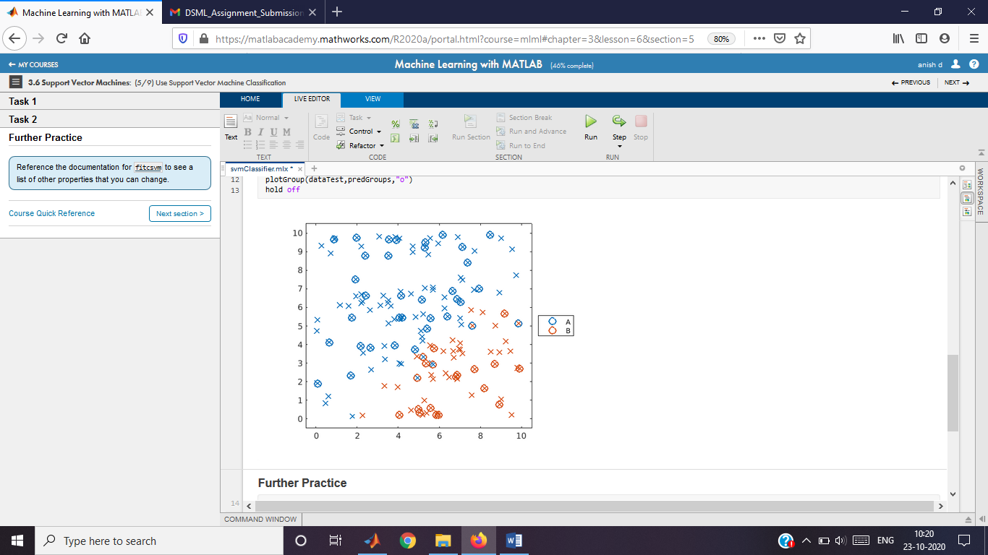

**Further Practice**

This function uses gscatter to create a formatted plot of grouped data.

function plotGroup(data,grp,mkr)

validateattributes(data,"table",{'nonempty','ncols',3})

% Plot data by group

colors = colororder;

p = gscatter(data.x,data.y,grp,colors([1 2 4],:),mkr,9);

% Format plot

[p.LineWidth] = deal(1.5);

legend("Location","eastoutside")

xlim([-0.5 10.5])

ylim([-0.5 10.5])

end

SVM with Concentric Data

Instructions are in the task pane to the left. Complete and submit each task one at a time.

This code loads, partitions, and plots the data.

load points

rng(123)

cvpt = cvpartition(points.group,"Holdout",0.38);

trainPoints = points(training(cvpt),:);

testPoints = points(test(cvpt),:);

plotGroup(points,points.group,"x")

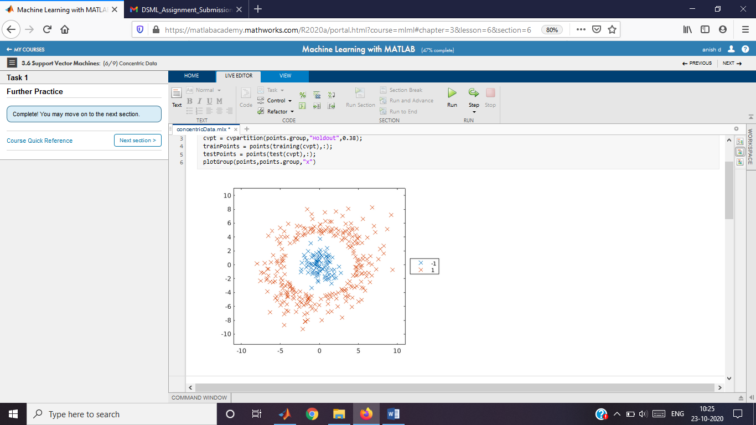

**Task 1**

mdl=fitcsvm(trainPoints,"group","KernelFunction","polynomial")

mdl =

ClassificationSVM  
 PredictorNames: {'x' 'y'}  
 ResponseName: 'group'  
 CategoricalPredictors: []  
 ClassNames: [-1 1]  
 ScoreTransform: 'none'  
 NumObservations: 237  
 Alpha: [8×1 double]  
 Bias: -3.4542  
 KernelParameters: [1×1 struct]  
 BoxConstraints: [237×1 double]  
 ConvergenceInfo: [1×1 struct]  
 IsSupportVector: [237×1 logical]  
 Solver: 'SMO'  
  
  
 Properties, Methods

err=loss(mdl,testPoints)

err = 0

Plot predicted groups.

predGroups = predict(mdl,testPoints);

plotGroup(points,points.group,"x")

hold on

plotGroup(testPoints,predGroups,"o")

hold off

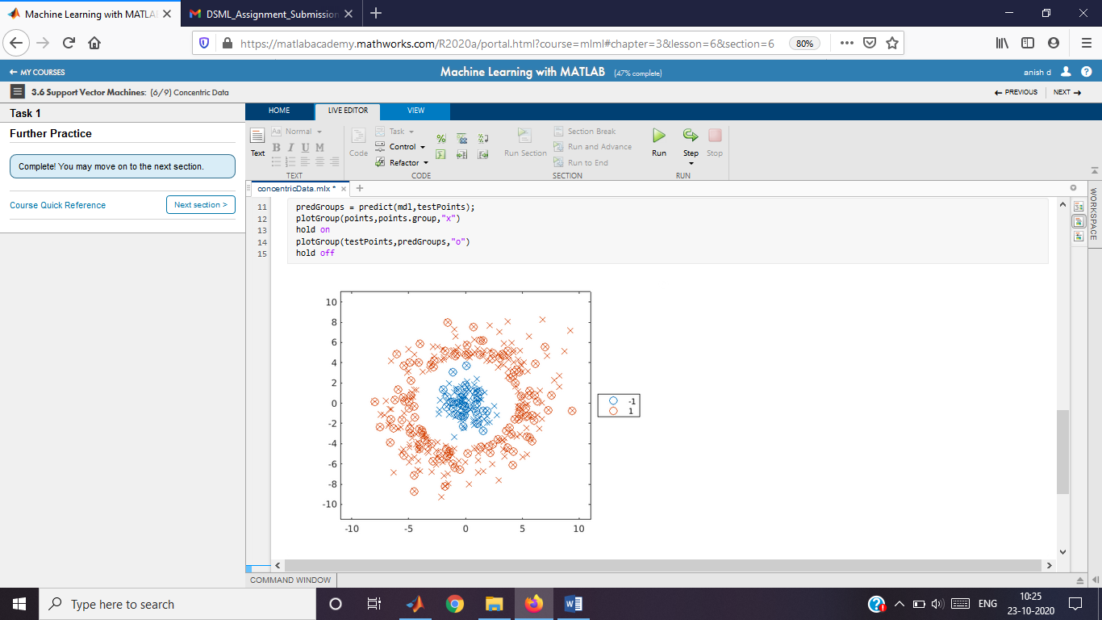

This function uses gscatter to create a formatted plot of grouped data.

function plotGroup(data,grp,mkr)

validateattributes(data,"table",{'nonempty','ncols',3})

% Plot data by group

colors = colororder;

p = gscatter(data.x,data.y,grp,colors([1 2 4],:),mkr,9);

% Format plot

[p.LineWidth] = deal(1.25);

legend("Location","eastoutside")

xlim([-11 11])

ylim([-11.5 11])

end

Heart Disease Analysis (numeric data)

Instructions are in the task pane to the left. Complete and submit each task one at a time.

This code loads and formats the data.

heartData = readtable("heartDataNum.txt");

heartData.HeartDisease = categorical(heartData.HeartDisease);

This code partitions the data into training and test sets.

pt = cvpartition(heartData.HeartDisease,"HoldOut",0.3);

hdTrain = heartData(training(pt),:);

hdTest = heartData(test(pt),:);

**Tasks 1 & 2**

mdl=fitcsvm(hdTrain,"HeartDisease")

mdl =

ClassificationSVM  
 PredictorNames: {'Age' 'Cholesterol' 'ExerciseDuration' 'METs' 'RestingHeartRate' 'RestingSystolic' 'RestingDiastolic' 'MaxHeartRate' 'PeakExSystolic' 'PeakExDiastolic' 'InducedSTDep'}  
 ResponseName: 'HeartDisease'  
 CategoricalPredictors: []  
 ClassNames: [false true]  
 ScoreTransform: 'none'  
 NumObservations: 299  
 Alpha: [171×1 double]  
 Bias: 0.3335  
 KernelParameters: [1×1 struct]  
 BoxConstraints: [299×1 double]  
 ConvergenceInfo: [1×1 struct]  
 IsSupportVector: [299×1 logical]  
 Solver: 'SMO'  
  
  
 Properties, Methods

mdl=fitcsvm(hdTrain,"HeartDisease","kernelFunction","gaussian")

mdl =

ClassificationSVM  
 PredictorNames: {'Age' 'Cholesterol' 'ExerciseDuration' 'METs' 'RestingHeartRate' 'RestingSystolic' 'RestingDiastolic' 'MaxHeartRate' 'PeakExSystolic' 'PeakExDiastolic' 'InducedSTDep'}  
 ResponseName: 'HeartDisease'  
 CategoricalPredictors: []  
 ClassNames: [false true]  
 ScoreTransform: 'none'  
 NumObservations: 299  
 Alpha: [169×1 double]  
 Bias: 0.4863  
 KernelParameters: [1×1 struct]  
 BoxConstraints: [299×1 double]  
 ConvergenceInfo: [1×1 struct]  
 IsSupportVector: [299×1 logical]  
 Solver: 'SMO'  
  
  
 Properties, Methods

Calculate the loss for the training and test sets

errTrain = resubLoss(mdl);

errTest = loss(mdl,hdTest);

disp("Training Error: " + errTrain)

Training Error: 0.19064

disp("Test Error: " + errTest)

Test Error: 0.39105

Heart Disease Analysis

Instructions are in the task pane to the left. Complete and submit each task one at a time.

This code loads and formats the data.

heartData = readtable("heartDataAll.txt");

heartData = convertvars(heartData,12:22,"categorical");

This code partitions the data into training and test sets.

pt = cvpartition(heartData.HeartDisease,"HoldOut",0.3);

hdTrain = heartData(training(pt),:);

hdTest = heartData(test(pt),:);

**Task 1**

mdl=fitcsvm(hdTrain,"HeartDisease","KernelFunction","gaussian")

mdl =

ClassificationSVM  
 PredictorNames: {1×21 cell}  
 ResponseName: 'HeartDisease'  
 CategoricalPredictors: [12 13 14 15 16 17 18 19 20 21]  
 ClassNames: [false true]  
 ScoreTransform: 'none'  
 NumObservations: 299  
 Alpha: [268×1 double]  
 Bias: 0.0278  
 KernelParameters: [1×1 struct]  
 BoxConstraints: [299×1 double]  
 ConvergenceInfo: [1×1 struct]  
 IsSupportVector: [299×1 logical]  
 Solver: 'SMO'  
  
  
 Properties, Methods

Calculate the loss for the training and test sets

errTrain = resubLoss(mdl);

errTest = loss(mdl,hdTest);

disp("Training Error: " + errTrain)

Training Error: 0.036789

disp("Test Error: " + errTest)

Test Error: 0.26416

Multiclass SVM

Instructions are in the task pane to the left. Complete and submit each task one at a time.

This code loads, partitions, and plots the data.

load groups

rng(0)

cvpt = cvpartition(groupData.group,"Holdout",0.35);

dataTrain = groupData(training(cvpt),:);

dataTest = groupData(test(cvpt),:);

plotGroup(groupData,groupData.group,"x")

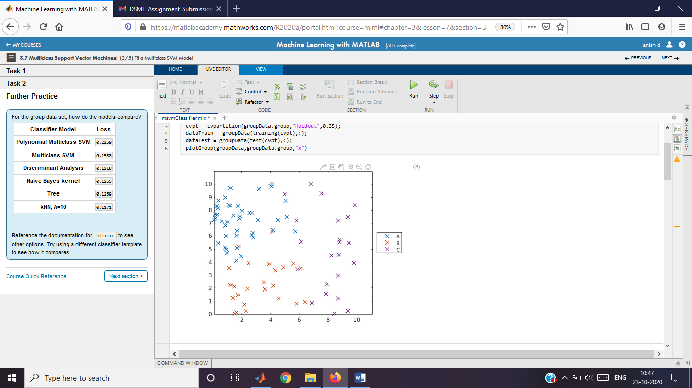

**Task 1**

mdlMSVM=fitcecoc(dataTrain,"group")

mdlMSVM =

ClassificationECOC  
 PredictorNames: {'x' 'y'}  
 ResponseName: 'group'  
 CategoricalPredictors: []  
 ClassNames: [A B C]  
 ScoreTransform: 'none'  
 BinaryLearners: {3×1 cell}  
 CodingName: 'onevsone'  
  
  
 Properties, Methods

errMSVM=loss(mdlMSVM,dataTest)

errMSVM = 0.1588

**Task 2**

t=templateSVM("KernelFunction","polynomial")

t =

Fit template for classification SVM.  
  
 Alpha: [0×1 double]  
 BoxConstraint: []  
 CacheSize: []  
 CachingMethod: ''  
 ClipAlphas: []  
 DeltaGradientTolerance: []  
 Epsilon: []  
 GapTolerance: []  
 KKTTolerance: []  
 IterationLimit: []  
 KernelFunction: 'polynomial'  
 KernelScale: []  
 KernelOffset: []  
 KernelPolynomialOrder: []  
 NumPrint: []  
 Nu: []  
 OutlierFraction: []  
 RemoveDuplicates: []  
 ShrinkagePeriod: []  
 Solver: ''  
 StandardizeData: []  
 SaveSupportVectors: []  
 VerbosityLevel: []  
 Version: 2  
 Method: 'SVM'  
 Type: 'classification'

mdlMSVM=fitcecoc(dataTrain,"group","Learners",t)

mdlMSVM =

ClassificationECOC  
 PredictorNames: {'x' 'y'}  
 ResponseName: 'group'  
 CategoricalPredictors: []  
 ClassNames: [A B C]  
 ScoreTransform: 'none'  
 BinaryLearners: {3×1 cell}  
 CodingName: 'onevsone'  
  
  
 Properties, Methods

errMSVM=loss(mdlMSVM,dataTest)

errMSVM = 0.2259

Plot predicted groups.

predGroups = predict(mdlMSVM,dataTest);

plotGroup(groupData,groupData.group,"x")

hold on

plotGroup(dataTest,predGroups,"o")

hold off

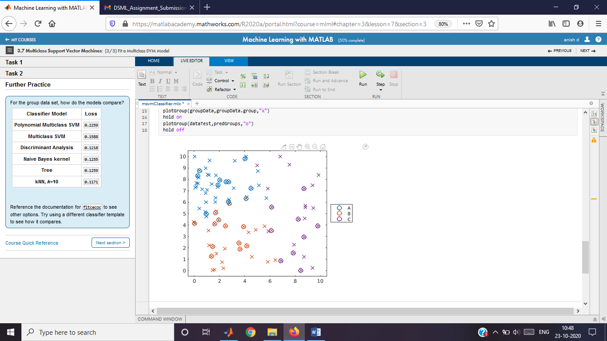

**Further Practice**

This function uses gscatter to create a formatted plot of grouped data.

function plotGroup(data,grp,mkr)

validateattributes(data,"table",{'nonempty','ncols',3})

% Plot data by group

colors = colororder;

p = gscatter(data.x,data.y,grp,colors([1 2 4],:),mkr,9);

% Format plot

[p.LineWidth] = deal(1.5);

legend("Location","eastoutside")

xlim([-0.5 10.5])

ylim([-0.5 10.5])

end

Heart Disease Analysis (numeric data)

Instructions are in the task pane to the left. Complete and submit each task one at a time.

This code loads and formats the data.

heartData = readtable("heartDataNumMulti.txt");

heartData.HeartDisease = categorical(heartData.HeartDisease);

This code partitions the data into training and test sets.

pt = cvpartition(heartData.HeartDisease,"HoldOut",0.3);

hdTrain = heartData(training(pt),:);

hdTest = heartData(test(pt),:);

**Tasks 1 & 2**

mdl = fitcecoc(hdTrain,"HeartDisease");

t=templateSVM("KernelFunction","gaussian")

t =

Fit template for classification SVM.  
  
 Alpha: [0×1 double]  
 BoxConstraint: []  
 CacheSize: []  
 CachingMethod: ''  
 ClipAlphas: []  
 DeltaGradientTolerance: []  
 Epsilon: []  
 GapTolerance: []  
 KKTTolerance: []  
 IterationLimit: []  
 KernelFunction: 'gaussian'  
 KernelScale: []  
 KernelOffset: []  
 KernelPolynomialOrder: []  
 NumPrint: []  
 Nu: []  
 OutlierFraction: []  
 RemoveDuplicates: []  
 ShrinkagePeriod: []  
 Solver: ''  
 StandardizeData: []  
 SaveSupportVectors: []  
 VerbosityLevel: []  
 Version: 2  
 Method: 'SVM'  
 Type: 'classification'

mdl = fitcecoc(hdTrain,"HeartDisease","Learners",t);

Calculate the loss for the training and test sets

errTrain = resubLoss(mdl);

errTest = loss(mdl,hdTest);

disp("Training Error: " + errTrain)

Training Error: 0.41806

disp("Test Error: " + errTest)

Test Error: 0.56643

Heart Disease Analysis

Instructions are in the task pane to the left. Complete and submit each task one at a time.

This code loads and formats the data.

heartData = readtable("heartDataAllMulti.txt");

heartData = convertvars(heartData,12:22,"categorical");

This code partitions the data into training and test sets.

pt = cvpartition(heartData.HeartDisease,"HoldOut",0.3);

hdTrain = heartData(training(pt),:);

hdTest = heartData(test(pt),:);

**Task 1**

mdl=fitcecoc(hdTrain,"HeartDisease")

mdl =

ClassificationECOC  
 PredictorNames: {1×21 cell}  
 ResponseName: 'HeartDisease'  
 CategoricalPredictors: [12 13 14 15 16 17 18 19 20 21]  
 ClassNames: [0 1 2 3 4]  
 ScoreTransform: 'none'  
 BinaryLearners: {10×1 cell}  
 CodingName: 'onevsone'  
  
  
 Properties, Methods

Calculate the loss for the training and test sets

errTrain = resubLoss(mdl);

errTest = loss(mdl,hdTest);

disp("Training Error: " + errTrain)

Training Error: 0.35452

disp("Test Error: " + errTest)

Test Error: 0.56014

User Knowledge Assessment

Instructions are in the task pane to the left. Complete and submit each task one at a time.

This code loads and formats the data.

knowledge = readtable("userKnowledge.txt");

knowledge.knowledgeScore = categorical(knowledge.knowledgeScore);

Partition the data into training and test sets.

rng(0)

pt = cvpartition(knowledge.knowledgeScore,"HoldOut",0.3);

kTrain = knowledge(training(pt),:)

kTrain = 181×6 table

|  | **studyTimeGoal** | **repetitionGoal** | **studyTimeSupporting** | **examSupporting** | **examGoal** | **knowledgeScore** |
| --- | --- | --- | --- | --- | --- | --- |
| **1** | 0 | 0 | 0 | 0 | 0 | veryLow |
| **2** | 0.0800 | 0.0800 | 0.1000 | 0.2400 | 0.9000 | high |
| **3** | 0.0600 | 0.0600 | 0.0500 | 0.2500 | 0.3300 | low |
| **4** | 0.1000 | 0.1000 | 0.1500 | 0.6500 | 0.3000 | middle |
| **5** | 0.0800 | 0.0800 | 0.0800 | 0.9800 | 0.2400 | low |
| **6** | 0.0900 | 0.1500 | 0.4000 | 0.1000 | 0.6600 | middle |
| **7** | 0.1000 | 0.1000 | 0.4300 | 0.2900 | 0.5600 | middle |
| **8** | 0.2000 | 0.1400 | 0.3500 | 0.7200 | 0.2500 | low |
| **9** | 0 | 0 | 0.5000 | 0.2000 | 0.8500 | high |
| **10** | 0.1800 | 0.1800 | 0.5500 | 0.3000 | 0.8100 | high |
| **11** | 0.0600 | 0.0600 | 0.5100 | 0.4100 | 0.3000 | low |
| **12** | 0.1000 | 0.1000 | 0.5200 | 0.7800 | 0.3400 | middle |
| **13** | 0.1000 | 0.1000 | 0.7000 | 0.1500 | 0.9000 | high |
| **14** | 0.2000 | 0.2000 | 0.7000 | 0.3000 | 0.6000 | middle |
| **15** | 0.1200 | 0.1200 | 0.7500 | 0.3500 | 0.8000 | high |
| **16** | 0.0500 | 0.0700 | 0.7000 | 0.0100 | 0.0500 | veryLow |
| **17** | 0.1500 | 0.3200 | 0.0500 | 0.2700 | 0.2900 | low |
| **18** | 0.2000 | 0.2900 | 0.2500 | 0.4900 | 0.5600 | middle |
| **19** | 0.1200 | 0.2800 | 0.2000 | 0.7800 | 0.2000 | low |
| **20** | 0.1000 | 0.2700 | 0.3100 | 0.2900 | 0.6500 | middle |
| **21** | 0.0600 | 0.2900 | 0.3500 | 0.7600 | 0.2500 | low |
| **22** | 0.0900 | 0.3000 | 0.6800 | 0.1800 | 0.8500 | high |
| **23** | 0.0400 | 0.2800 | 0.5500 | 0.2500 | 0.1000 | veryLow |
| **24** | 0.1500 | 0.2750 | 0.8000 | 0.2100 | 0.8100 | high |
| **25** | 0.1500 | 0.2950 | 0.7500 | 0.6500 | 0.2400 | low |
| **26** | 0.1800 | 0.3200 | 0.0400 | 0.1900 | 0.8200 | high |
| **27** | 0.0600 | 0.3500 | 0.1200 | 0.4300 | 0.2900 | low |
| **28** | 0.0900 | 0.3300 | 0.3100 | 0.2600 | 0 | veryLow |
| **29** | 0.1900 | 0.3800 | 0.3800 | 0.4900 | 0.4500 | middle |
| **30** | 0.0200 | 0.3300 | 0.3600 | 0.7600 | 0.1000 | low |
| **31** | 0.2000 | 0.4900 | 0.6000 | 0.2000 | 0.7800 | high |
| **32** | 0.1400 | 0.4900 | 0.5500 | 0.2900 | 0.6000 | middle |
| **33** | 0.1150 | 0.3500 | 0.6500 | 0.2700 | 0.0400 | veryLow |
| **34** | 0.1700 | 0.3600 | 0.8000 | 0.1400 | 0.6600 | middle |
| **35** | 0.1300 | 0.3900 | 0.8500 | 0.3800 | 0.7700 | high |
| **36** | 0.0900 | 0.5100 | 0.0200 | 0.1800 | 0.6700 | middle |
| **37** | 0.0600 | 0.5000 | 0.0900 | 0.2800 | 0.2500 | low |
| **38** | 0.0900 | 0.5500 | 0.1200 | 0.7800 | 0.0500 | low |
| **39** | 0.1800 | 0.7200 | 0.3700 | 0.2900 | 0.5500 | middle |
| **40** | 0.1000 | 0.6000 | 0.3300 | 0.4200 | 0.2600 | low |
| **41** | 0.2000 | 0.6800 | 0.7300 | 0.4800 | 0.2800 | low |
| **42** | 0.2400 | 0.5800 | 0.7600 | 0.8000 | 0.2800 | middle |
| **43** | 0.2900 | 0.0600 | 0.1900 | 0.5500 | 0.5100 | middle |
| **44** | 0.2800 | 0.1000 | 0.1200 | 0.2800 | 0.3200 | low |
| **45** | 0.3100 | 0.1000 | 0.4100 | 0.4200 | 0.7500 | high |
| **46** | 0.2900 | 0.1500 | 0.3300 | 0.6600 | 0.0800 | veryLow |
| **47** | 0.3000 | 0.2000 | 0.5200 | 0.3000 | 0.5300 | middle |
| **48** | 0.2800 | 0.1600 | 0.6900 | 0.3300 | 0.7800 | high |
| **49** | 0.2550 | 0.1800 | 0.5000 | 0.4000 | 0.1000 | veryLow |
| **50** | 0.2450 | 0.1000 | 0.7100 | 0.2600 | 0.2000 | veryLow |
| **51** | 0.2950 | 0.2000 | 0.8600 | 0.4400 | 0.2800 | low |
| **52** | 0.3200 | 0.1200 | 0.7900 | 0.7600 | 0.2400 | low |
| **53** | 0.2500 | 0.2900 | 0.1500 | 0.4800 | 0.2600 | low |
| **54** | 0.2700 | 0.1000 | 0.1000 | 0.7000 | 0.2500 | low |
| **55** | 0.2480 | 0.3000 | 0.3100 | 0.2000 | 0.0300 | veryLow |
| **56** | 0.3250 | 0.2500 | 0.3800 | 0.3100 | 0.7900 | high |
| **57** | 0.2900 | 0.2900 | 0.4000 | 0.7800 | 0.1800 | low |
| **58** | 0.2900 | 0.3000 | 0.5200 | 0.0900 | 0.6700 | middle |
| **59** | 0.2510 | 0.2650 | 0.5700 | 0.6000 | 0.0900 | veryLow |
| **60** | 0.2550 | 0.3050 | 0.8600 | 0.6200 | 0.1500 | low |
| **61** | 0.2950 | 0.2500 | 0.7300 | 0.7700 | 0.1900 | low |
| **62** | 0.2580 | 0.2500 | 0.2950 | 0.3300 | 0.7700 | high |
| **63** | 0.2900 | 0.2500 | 0.2900 | 0.2900 | 0.5700 | middle |
| **64** | 0.2430 | 0.2700 | 0.0800 | 0.4200 | 0.2900 | low |
| **65** | 0.2700 | 0.2800 | 0.1800 | 0.4800 | 0.2600 | low |
| **66** | 0.2990 | 0.3200 | 0.3100 | 0.3300 | 0.8700 | high |
| **67** | 0.3000 | 0.2700 | 0.3100 | 0.3100 | 0.5400 | middle |
| **68** | 0.2950 | 0.2900 | 0.3100 | 0.7600 | 0.1000 | low |
| **69** | 0.2900 | 0.3000 | 0.5600 | 0.2500 | 0.6700 | middle |
| **70** | 0.2600 | 0.2800 | 0.6000 | 0.2900 | 0.5900 | middle |
| **71** | 0.3050 | 0.2550 | 0.6300 | 0.4000 | 0.5400 | middle |
| **72** | 0.3200 | 0.2700 | 0.5200 | 0.8100 | 0.3000 | middle |
| **73** | 0.2990 | 0.2950 | 0.8000 | 0.3700 | 0.8400 | high |
| **74** | 0.2760 | 0.2550 | 0.8100 | 0.2700 | 0.3300 | low |
| **75** | 0.3200 | 0.2800 | 0.7200 | 0.8900 | 0.5800 | high |
| **76** | 0.3290 | 0.5500 | 0.0200 | 0.4000 | 0.7900 | high |
| **77** | 0.2950 | 0.5900 | 0.2900 | 0.3100 | 0.5500 | middle |
| **78** | 0.2850 | 0.6400 | 0.1800 | 0.6100 | 0.4500 | middle |
| **79** | 0.2650 | 0.6000 | 0.2800 | 0.6600 | 0.0700 | veryLow |
| **80** | 0.3150 | 0.6900 | 0.2800 | 0.8000 | 0.7000 | high |
| **81** | 0.3250 | 0.6100 | 0.4600 | 0.3200 | 0.8100 | high |
| **82** | 0.3050 | 0.5500 | 0.5000 | 0.1100 | 0.3330 | low |
| **83** | 0.3000 | 0.8500 | 0.5400 | 0.2500 | 0.8300 | middle |
| **84** | 0.2990 | 0.7000 | 0.9500 | 0.2200 | 0.6600 | high |
| **85** | 0.2650 | 0.7600 | 0.8000 | 0.2800 | 0.2800 | low |
| **86** | 0.2550 | 0.7200 | 0.7200 | 0.6300 | 0.1400 | low |
| **87** | 0.3900 | 0.0500 | 0.0200 | 0.0600 | 0.3400 | low |
| **88** | 0.4500 | 0.0400 | 0.1800 | 0.5500 | 0.0700 | veryLow |
| **89** | 0.4000 | 0.1200 | 0.4100 | 0.1000 | 0.6500 | middle |
| **90** | 0.3700 | 0.0600 | 0.3200 | 0.7800 | 0.1000 | low |
| **91** | 0.4100 | 0.0900 | 0.5800 | 0.1800 | 0.5800 | middle |
| **92** | 0.3800 | 0.0100 | 0.5300 | 0.2700 | 0.3000 | low |
| **93** | 0.3300 | 0.0400 | 0.5000 | 0.5500 | 0.1000 | veryLow |
| **94** | 0.4200 | 0.1500 | 0.6600 | 0.7800 | 0.4000 | middle |
| **95** | 0.3900 | 0.1500 | 0.8100 | 0.2200 | 0.2900 | low |
| **96** | 0.4200 | 0.2100 | 0.8700 | 0.5600 | 0.4800 | middle |
| **97** | 0.3650 | 0.2430 | 0.1900 | 0.2400 | 0.3500 | low |
| **98** | 0.4800 | 0.3000 | 0.1500 | 0.6500 | 0.7700 | high |
| **99** | 0.4900 | 0.2450 | 0.3800 | 0.1400 | 0.8600 | high |
| **100** | 0.3340 | 0.2950 | 0.3300 | 0.3200 | 0.3000 | low |
| **⋮** |  |  |  |  |  |  |

kTest = knowledge(test(pt),:);

**Fit model**

Fit classifier and calculate loss.

mdl = fitctree(kTrain,"knowledgeScore");

errRate = loss(mdl,kTest)

errRate = 0.1030

**Further Practice**

Breast Cancer Detection

Instructions are in the task pane to the left. Complete and submit each task one at a time.

This code loads and formats the data.

bcDiag = readtable("breastCancerData.txt");

bcDiag.diagnosis = categorical(bcDiag.diagnosis);

Partition the data into training and test sets.

pt = cvpartition(bcDiag.diagnosis,"HoldOut",0.3);

bcTrain = bcDiag(training(pt),:);

bcTest = bcDiag(test(pt),:);

**Task 1**

Fit classifier and calculate loss.

mdl = fitcknn(bcTrain,"diagnosis","NumNeighbors",5);

errRate = loss(mdl,bcTest)

errRate =

0.076627185825415

**Task 2**

Calculate false negative rate.

p = predict(mdl,bcTest);

falseNeg = mean((bcTest.diagnosis == "M") & (p == "B"))

falseNeg =

0.041176470588235

confusionchart(bcTest.diagnosis,p);

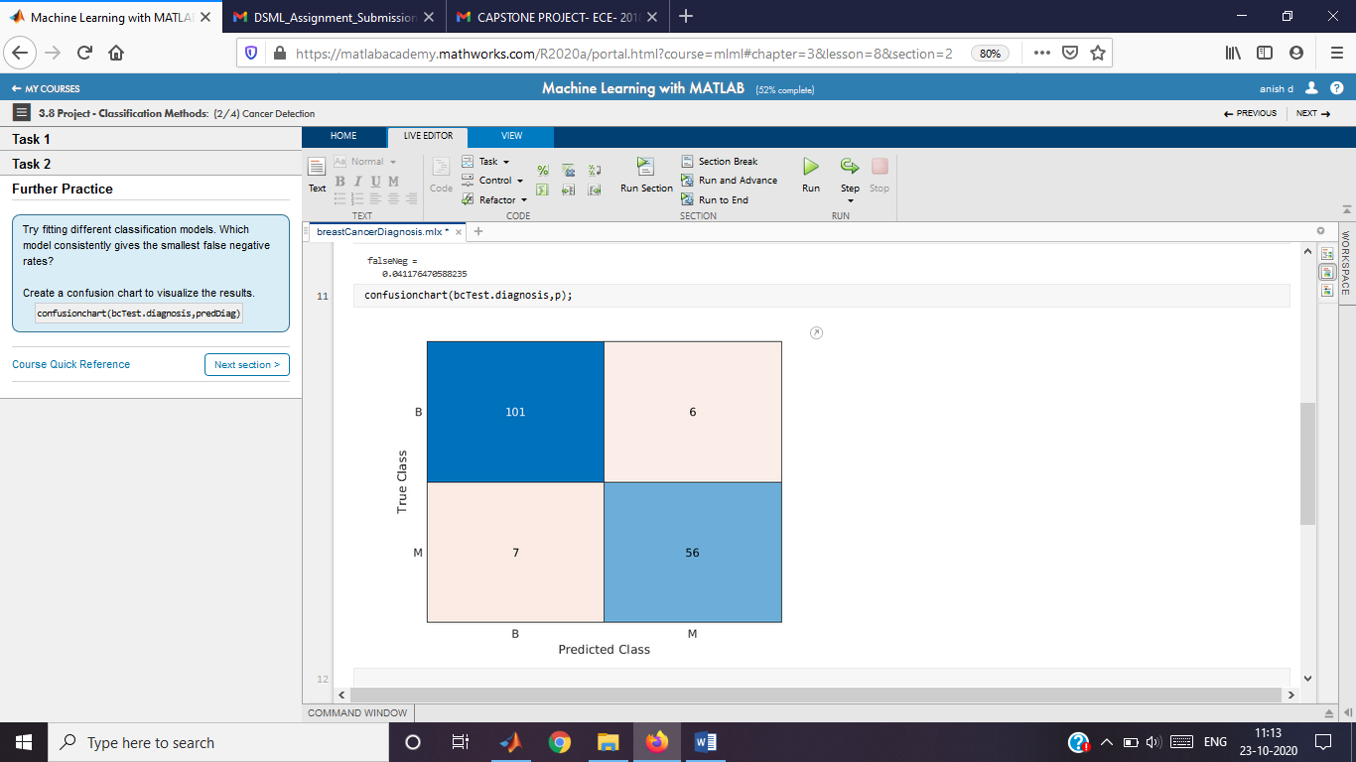

**Further Practice**

confusionchart(bcTest.diagnosis,p)

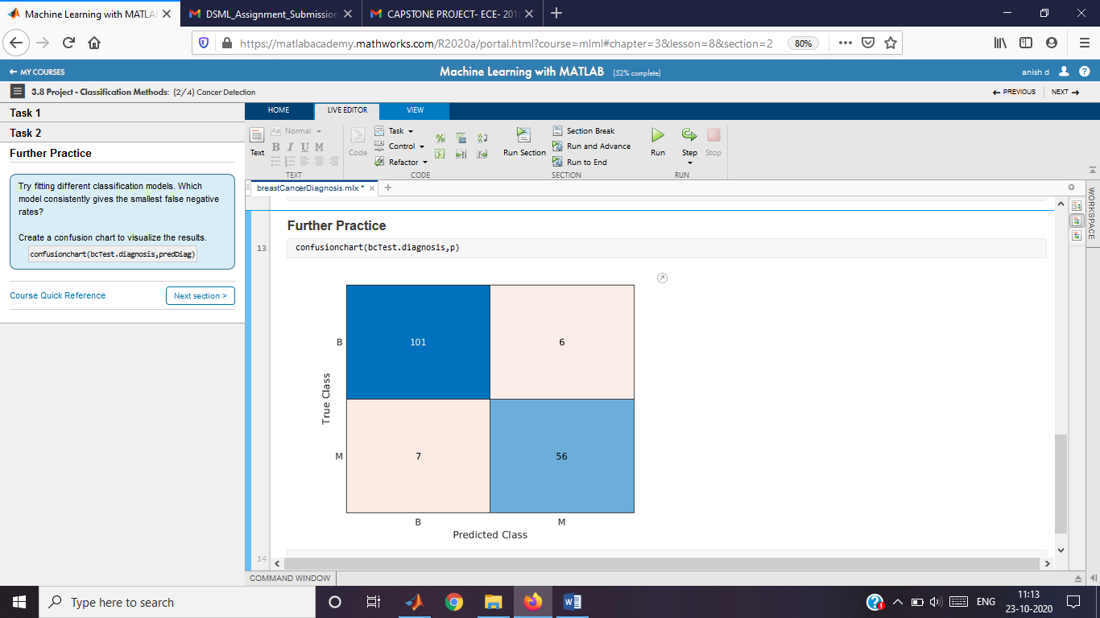

Mushroom Edibility

Instructions are in the task pane to the left. Complete and submit each task one at a time.

This code loads and formats the data.

mushrooms = readtable("mushrooms.txt");

mushrooms = convertvars(mushrooms,vartype("cellstr"),"categorical");

Partition the data into training and test sets.

pt = cvpartition(mushrooms.edibility,"HoldOut",0.3);

mTrain = mushrooms(training(pt),:);

mTest = mushrooms(test(pt),:);

**Task 1**

Use Naive Bayes classification to predict edibility.

mdlNB = fitcnb(mTrain,"edibility","DistributionNames","mvmn");

errRateNB = loss(mdlNB,mTest)

errRateNB =

0.166666666666667

**Task 2**

Use *k*-NN classification to predict edibility.

mdlKNN = fitcknn(mTrain,"edibility","NumNeighbors",2);

errRateKNN = loss(mdlKNN,mTest)

errRateKNN =

0.112603174603175

Wine Quality

Instructions are in the task pane to the left. Complete and submit each task one at a time.

This code loads and formats the data.

redData = readtable("redWine.txt");

redData.QCLabel = categorical(redData.QCLabel);

Partition the data into training and test sets.

pt = cvpartition(redData.QCLabel,"HoldOut",0.3);

redWineTrain = redData(training(pt),:);

redWineTest = redData(test(pt),:);

**Task 1**

Fit model and calculate loss.

mdl = fitcdiscr(redWineTrain,"QCLabel");

errRate = loss(mdl,redWineTest)

errRate =

0.425631850607930